Forecasting Multiplicative Seasonality Time-Series with Machine Learning, Time-Series, and Hybrid Models: Insights from Simulation-based Assessments

Jannatul Ferdous Nisha
Department of Statistics and Data Science, Jahangirnagar University, Savar, Dhaka, Bangladesh
ORCID ID: 0009-0004-2889-1703

Kazi Arifur Rahaman
Security Services Division, Ministry of Home Affairs, Dhaka, Bangladesh
ORCID ID: 0009-0002-3015-8661

Farhana Akter Bina
Department of Statistics and Data Science, Jahangirnagar University, Savar, Dhaka, Bangladesh
ORCID ID: 0000-0002-5352-1489

Mustafizur Rahman
WTO Section-3, Ministry of Commerce, Dhaka-1000, Bangladesh
ORCID ID: 0009-0003-7870-1931

Md. Moyazzem Hossain
Department of Statistics and Data Science, Jahangirnagar University, Savar, Dhaka, Bangladesh
ORCID ID: 0000-0003-3593-693

and
Rumana Rois
Department of Statistics and Data Science, Jahangirnagar University, Savar, Dhaka, Bangladesh
ORCID ID: 0000-0002-0751-7104

Abstract

A prevalent feature of time-series data is multiplicative seasonality, in which the seasonal effects change according to the level of the series. The widely used ARIMA model cannot enhance prediction performance in this situation. By incorporating alternative models into the analysis, researchers can better understand and forecast patterns in time-series data with complex seasonality. Therefore, this study investigates the performance of various forecasting models on time-series data exhibiting multiplicative seasonality. The authors evaluated eleven models, including classical time-series methods like ARIMA and ETS, machine learning models like TBATS, ANN, and several hybrid combinations such as ETS-ARIMA, ETS-TBATS, TBATS-ARIMA TBATS-ETS, TBATS-ANN, STL-ARIMA, STL-ETS. Our analysis utilized both large-scale simulations and real-world datasets to provide a comprehensive assessment. In real-world data applications, the ETS model excelled in forecasting trends with multiplicative seasonality, while SARIMA outperformed other models in datasets with no trend multiplicative seasonality. However, simulation-based analyses revealed more nuanced results. The ETS-ARIMA hybrid model demonstrated superior performance on the UKgas dataset, particularly with simulation sizes of 500 and data sizes of 100, and 200. For the fdeaths dataset, TBATS produced the best results in terms of MSE and RMSE for a simulation size of 500 and data size of 100, whereas the ETS-TBATS model was more effective in terms of MAE and MAPE. Additionally, the TBATS-ARIMA hybrid model consistently outperformed others with data sizes of 200. These findings underscore the importance of selecting customized models based on dataset characteristics to achieve accurate forecasting in time-series data with multiplicative seasonality.

Keywords: Hybrid model; Machine learning; Simulation; Time series.

- Introduction

Forecasting time series data with multiplicative seasonality is quite challenging since these data include complex patterns. Commonly used time-series models like the Autoregressive Integrated Moving Average (ARIMA) model are suitable for time-series data with additive seasonality, as seasonal fluctuations remain constant over time (Bajaj, 2023; Hyndman & Athanasopoulos, 2021; Rehal, 2022). However, Seasonal Autoregressive Integrated Moving Average (SARIMA) is a variant of ARIMA that considers seasonal components and is useful for modeling multiplicative seasonality (Hyndman & Athanasopoulos, 2021; Suhartono, 2011). Because its amplitude varies with series level, SARIMA is a better way to depict this multiplicative nature. Moreover, Exponential Smoothing State Space (ETS) models are linear as well as non-linear forecasting methods that incorporate any type of trends and seasonality in time series data (Hyndman & Athanasopoulos, 2021; Shumway, R. H., & Stoffer, 2017a). ETS models provide a robust framework for time series forecasting, particularly when dealing with multiplicative seasonality, making them valuable tools for analysts and decision-makers (Hyndman & Athanasopoulos, 2021; Shumway, R. H., & Stoffer, 2017b). Traditional ETS models and SARIMA models have been widely used for their simplicity and robustness in handling linear trends and seasonal components (Hyndman & Athanasopoulos, 2018; Shumway, R. H., & Stoffer, 2017b). These models have become the standard for time series forecasting, particularly in industries where understanding and modeling seasonality are crucial (Makridakis, S., Wheelwright, S. C., & Hyndman, 1998). However, as data complexity increases, with non-linear patterns and multiplicative seasonality becoming more prevalent, traditional models often struggle to provide accurate forecasts. In response, more advanced approaches such as Trigonometric Box-Cox ARIMA Trend Seasonal Components (TBATS) and Artificial Neural Networks (ANN) have gained prominence. TBATS is specifically designed to handle complex seasonal patterns by allowing multiple seasonal cycles and flexible trend components, making it well-suited for time series with intricate seasonal structures (Taylor et al., 2018).

Machine learning models, particularly ANN, have become increasingly popular for time series forecasting due to their ability to capture non-linear relationships within the data (Kim, 2016). ANN, while powerful, often requires large datasets and substantial computational resources to outperform traditional methods (Zhang, 2003). Despite their potential, the application of ANN to time series forecasting remains an area of active research, with ongoing efforts to improve their interpretability and efficiency (Hewamalage et al., 2020). While TBATS and ANN may be effective for handling complex seasonal patterns, they can also be more computationally intensive and require a higher level of expertise to implement compared to traditional models. Additionally, the increased complexity of these advanced approaches may make it more challenging to interpret and communicate the results to stakeholders.

The recent surge in hybrid models combining traditional statistical techniques with machine learning approaches reflects an effort to leverage the strengths of both paradigms. Hybrid models like STL-ARIMA, STL-ETS, TBATS-ARIMA, TBATS-ETS, and TBATS-ANN aim to integrate the robustness of classical models with the flexibility of machine learning methods, potentially offering superior performance in various forecasting scenarios (Hyndman & Athanasopoulos, 2018; Khashei & Bijari, 2011; Livera et al., 2010a). The underlying idea is that by combining different methods, the limitations of one approach can be mitigated by the strengths of another, leading to improved forecasting accuracy (Smith-miles & Wang, 2006). Despite the theoretical advantages of hybrid models, there is still an ongoing debate regarding their practical utility. Some studies suggest that traditional models like ETS and SARIMA often outperform more complex hybrids in real-world applications (Makridakis et al., 2020). However, other research indicates that hybrid models can excel in specific contexts, particularly when dealing with large datasets or data exhibiting complex seasonal patterns (Kang, 2020).

Ultimately, the choice between using traditional models or hybrid models depends on the specific characteristics of the data and the goals of the analysis. While traditional models may be easier to implement and interpret, hybrid models may offer superior performance in certain scenarios. It is important for analysts to carefully consider the nature of their data and the complexity of the patterns present before deciding on the most appropriate modeling approach. This paper contributes to the ongoing discourse by conducting a comprehensive simulation-based assessment of eleven different models, including ETS, SARIMA, TBATS, ANN, STL-ARIMA, STL-ETS, ETS-ARIMA, ETS-TBATS, TBATS-ETS, TBATS-ARIMA, and TBATS-ANN. By evaluating their performance with multiplicative seasonality across various trend scenarios, this study aims to provide valuable insights into the conditions under which certain models outperform others, offering guidance for researchers in selecting the most appropriate models for complex forecasting tasks.

- Method and Materials

2.1 Data Description

In this study, the authors have conducted experiments with two real-world time series data. The descriptions of the datasets are shown in Table 1. It also shows the number of observations in the train and test set. The quarterly and monthly “Ukgas” and “fdeaths” time series data are shown in Figure 1. These two datasets—“UKgas” and “fdeaths”—are classic benchmark time series widely used in the forecasting literature (Hyndman & Athanasopoulos, 2018). UKgas (1960–1986) exhibits a clear increasing trend with multiplicative seasonality, while fdeaths (1972–1978) displays multiplicative seasonality without a trend. Although these datasets are not recent, they were selected specifically because they are well-understood, publicly available, and serve as standard examples for validating forecasting methods under controlled conditions. The goal of this study is methodological comparison rather than updating historical forecasts. Therefore, these datasets provide a reproducible foundation for evaluating model performance.

Table 1. Details of the Time Series Datasets

Time Series | Description | ETS | Size (Training, Test)
Ukgas | UK Quarterly Gas Consumption (1960-1986) | M, A, M | 76,32
fdeaths | Monthly female Deaths from Lung Diseases in the UK (1972-1978) | M, N, M | 50,22
Note: M: multiplicative errors; A: additive seasonality; N: no trend

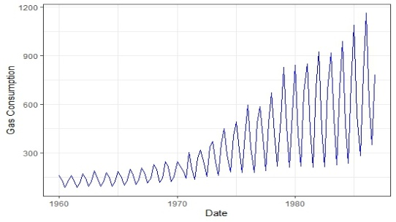  (a) | 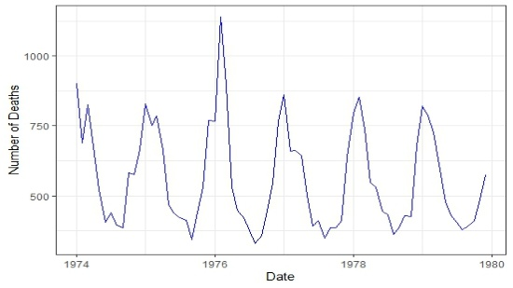  (b)

Figure 1. (a) UK Quarterly Gas Consumption; (b) Monthly Female Deaths from Lung Diseases in the UK

Initially, the use of gas in the UK might not have been widespread at first, but it has been rising consistently over time, with an especially significant rise since 1973. This series presents an increasing trend with multiplicative seasonality in Figure 1 (a). It is also observed that the deaths might not have been widespread at first, the data show that it had been significantly rising in 1976. This series presented no trend with multiplicative seasonality (Figure 1 (b)).

  - Exploratory Data Analysis

Figure 2 shows seasonal sub-series plots for both trends with multiplicative seasonality and no trend with multiplicative seasonality. Seasonal sub-series plots collect and plot together the seasons within the data, in this case, the quarters and months.

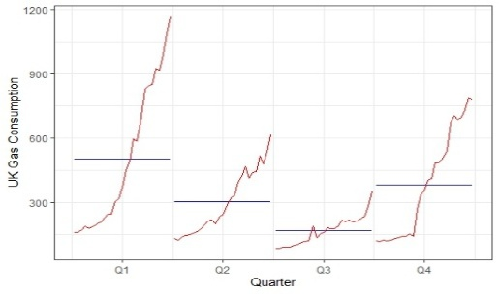  (a) | 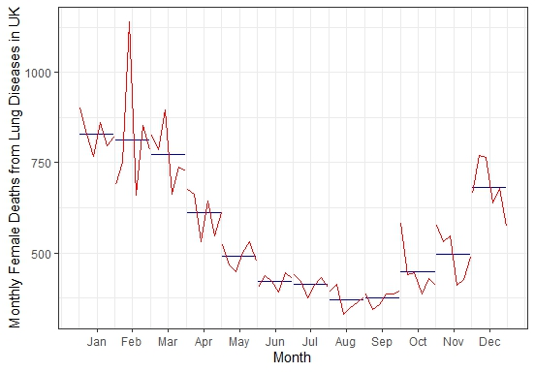  (b)
Figure 2. (a) Seasonal Subseries Plot of UK Gas Consumption; (b) Seasonal Subseries Plot of Female Deaths in the UK

UKgas data reached in peak point in the first quartile (Q1) and fell to its lowest point in the third quartile (Q3). The seasonal pattern might be seen clearly in this kind of display, which also shows how seasonality changes over time with trends (Figure 2 (a)). The maximum deaths were in January and February. August and September saw the lowest number of deaths from lung diseases. From the figure, it is clearly observed how seasonality evolves over time (Figure 2 (b)).

2.3 Time Series Models

Some general and broadly used classes of models are considered in this study. In particular, ETS, ARIMA, TBATS, ANN, STL-ARIMA, STL-ETS, ETS-ARIMA, ETS-TBATS, TBATS-ARIMA, TBATS-ETS, and TBATS-ANN models.

Autoregressive Integrated Moving Average Model (ARIMA)

ARIMA stands out as a highly promising linear forecasting model given below

$Y_{t}+φ_{1}Y_{t-1}+…+φ_{i}Y_{t-p}=Z_{t}$+$θ_{1}Z_{t-1}$+…+$θ_{j}Z_{t-j}$ (1)

where, {$Z_{t}$} ~ WN (0,$σ^{2})$, $Y_{t}$ represents time series values. $φ_{i} (i=1,2,…,p)$ are autoregressive (AR) coefficients and $θ_{j} (j=1,2,…,q)$ are moving average (MA) coefficients. When dealing with a particular time series dataset, the selection of the simplest ARIMA model, along with its specific parameter values, is crucial in ensuring the model’s effectiveness (Panigrahi et al., 2021).

Seasonal Autoregressive Integrated Moving Average Model (SARIMA)

A seasonal ARIMA known as the SARIMA model is defined as $ARIMA(p,d,q)×{(P,D,Q)}^{s}$ process with seasonal period s,

$ϕ\left(B\right)ϕ\left(B^{s}\right){(1-B)}^{d}{(1-B^{s})}^{D}y_{t}=θ\left(B\right) Θ\left(B^{s}\right)Z_{t}$, (2)
where $\left\{Z_{t}\right\}\sim WN\left(0,σ^{2}\right)$, $B$ is the Backshift operator, and the polynomial $ϕ\left(B\right)$,$Φ\left(B^{s}\right)$, $θ\left(B\right)$, and $Θ\left(B^{s}\right)$ are defined as $\left(1-ϕ_{1}B-…-ϕ_{p}B^{p}\right)$,$\left(1-Φ_{1}B^{s}-…-Φ_{p}B^{sP}\right)$, $\left(1+θ_{1}B+…+θ_{p}B^{p}\right)$, and $(1+Θ_{1}B^{s}+…+Θ_{Q}B^{sQ})$, respectively. Similar to the non-seasonal parts of the model, the seasonal part of the model includes backshifts of the seasonal period (Hyndman & Athanasopoulos, 2018).

Exponential Smoothing with Error, Trend, and Seasonality (ETS)

Exponential Smoothing with Error, Trend, and Seasonality (ETS) is a forecasting method that models time series data by decomposing it into three components: error, trend, and seasonality. The ETS model uses weighted averages of past observations, with weights decreasing exponentially over time. It adapts to different patterns by allowing for various configurations of trend and seasonality components, making it suitable for diverse time series data (Gardner, 1985).

The core ETS model consists of two primary equations: one for forecasting and one for smoothing. In ETS terminology, the model described corresponds to (M, N, A), signifying a model with multiplicative errors, no trend, and additive seasonality. Then the model is

$y_{t}=\left(l_{t-1}+s_{t-m}\right)\left(1+ε_{t}\right)$ $l_{t}=l_{t-1}+α\left(l_{t-1}+s_{t-m}\right)ε_{t}$ (3)
$s_{t}=s_{t-m}+γ\left(l_{t-1}+s_{t-m}\right)ε_{t}$

This state space formulation can be transformed into a forecast and a smoothing equation (Hyndman & Athanasopoulos, 2018).

Seasonal-Trend decomposition procedure based on LOESS (STL) Model

The STL model was introduced by Cleveland RB as a classical time series decomposition method. It distinguishes itself from traditional decomposition techniques by offering more resilient components for breaking down time series data, particularly when dealing with outliers (Yang et al., 2021a). The STL model is a method used to break down a seasonal time series into three distinct parts: the trend component, the seasonal component, and the residual (error) component are denoted by , , and respectively, for . Then,

$X_{t}=T_{t}+S_{t}+R_{t}$. (4)

The STL model’s algorithm involves a series of smoothing operations, all of which, except for one, utilize the same smoothing technique called locally weighted regression or loess (Erő & Szűcs, 1974). The STL is built around two recursive procedures: The inner loop updates the trend and seasonal components during each iteration. The outer loop includes the inner loop and computes robustness weights. In essence, the core of STL is the inner loop. In the outer loop, the trend and seasonal components obtained in the inner loop are used to compute the remainder component. $R_{t}^{k+1}=X_{t}-S_{t}^{k+1}-T_{t}^{k+1}$(Yang et al., 2021b).

Trigonometric Seasonality, Box-Cox transformation, ARMA errors, Trend, Seasonal Components (TBATS) Model

TBATS model was introduced in 2011 and accounts for multiseasonality with arguments TBATS ($ω,\{p,q\},φ,\{<m_{1},k_{1}>,<m_{2},k_{2}>,…,<m_{T},k_{T}>\})$
where, $ω$ is a Box-Cox transformation, , are ARMA parameters, $φ$ is a damping parameter, $m_{1,…,}m_{T}$ are seasonal periods, $k_{1,…,}k_{T}$ are the number of Fourier series pairs.
The model can be written as

$y_{t}^{(ω)}=l_{t-1}+φb_{t-1}+\sum_{i=1}^{T}{s_{t-1}^{(i)}}+{αd}_{t}b_{t}=b_{t-1}+βd_{t}$
$s_{t}^{(i)}=\sum_{j=1}^{k_{i}}{s_{j,t}^{(i)}}$ (5)
$s_{j,t}^{(i)}=s_{j,t-1}^{(i)}\cos{λ_{j}^{(i)}+s_{j,t-1}^{*}}\sin{λ_{j}^{(i)}+γ_{1}^{(i)}d_{t}}$
$s_{j,t}^{*(i)}={-s}_{j,t-1}^{(i)}\sin{λ_{j}^{(i)}+s_{j,t-1}^{*}}\cos{λ_{j}^{(i)}+γ_{2}^{(i)}d_{t}}$
$λ_{j}^{(i)}=\frac{2πj}{m_{i}}.$
Here, $i=1,…,T$, $d_{t}$is an ARMA (p, q) process, $α,β,γ_{1} and γ_{2}$ are smoothing parameters, $l_{0}$ is an initial level, and $b_{0}$ is a slope value (Brożyna et al., 2018).

Artificial Neural Network (ANN) Model

Artificial Neural Networks (ANNs) have emerged as a highly effective alternative to ARIMA models. One of these is their universal approximation capability, meaning that ANNs can accurately estimate any nonlinear continuous function to a desired level of precision (G. Zhang et al., 1998). A single hidden layer feedforward ANN with one output node is most commonly used in forecasting applications (Zhang & Qi, 2005; Zhang, 2003). An ANN has the following output

$y_{t}=∅_{0}+\sum_{j=1}^{q}{∅_{j}g}(θ_{0j}+\sum_{i=1}^{p}{θ_{ij}y_{t-i}})+ε_{t}$. (6)

Here, $∅_{j}$ $\left(j=1,2,…,q\right)$, $θ_{ij}$ $\left(i=1,2,…,p;j=1,2,…,q\right)$are the weights, $∅_{0}$ and $θ_{0j}$ are biased terms and $ε_{t}$ is the white noise. So far ANNs have been very effective for modeling nonlinearly generated time series but provided mixed results for linear problems (Khandelwal et al., 2015).

2.4 Hybrid Model Combination Framework

To ensure transparency and reproducibility, we provide a detailed description of how each hybrid model was constructed. In all hybrid approaches, two models are combined sequentially: the first model is fitted to the original time series, and the second model is fitted to the residuals from the first model. The final forecast is the sum of the first model's forecast and the second model's forecast of the residuals. This residual-based combination strategy is standard in the hybrid forecasting literature (Zhang, 2003, Hasan et al., 2025, Qureshi et al., 2025). Algorithm 1, which is based on the approach suggested by (Zhang, 2003, Hasan et al., 2025, Qureshi et al., 2025), formalizes the framework for this hybrid creation.

Algorithm 1: Hybrid Model-Based Forecasting for Time Series data
Input: Original time series data
1: First-Stage Modeling:
- Fit a primary time series model to the original time series data .
- Generate first-stage forecast
- Calculate the residuals .
2: Second-Stage (Residual) Modeling:
- Fit a secondary model (another time series model) to the residual series .
- Obtain the residual forecasts .
3: Forecast Aggregation:
- Calculate the final hybrid forecast by combining the first-stage forecast and the residuals forecast: .
Return: Final hybrid forecast

2.5 Forecasting Accuracy Metrics

Four important metrics were used to assess the hybrid models' forecasting performance: Mean Squared Error (MSE), Root Mean Squared Error (RMSE), Mean Absolute Error (MAE), Mean Absolute Percentage Error (MAPE). These metrics were calculated as follows:

,
,
,
,

where indicates the number of observations, denotes the original values, and represents the forecasted values (Hyndman & Athanasopoulos, 2018).

- Result

3.1 Forecast Evaluation of the Models

To evaluate the comparative performance, we have considered eleven comparative models. Table 2 provides an evaluation of the forecasting accuracy measures of all those eleven models by applying to the “UKgas” and “fdeaths” data. Models are re-identified and re-estimated with each step and forecasts are generated and evaluated against actual observations using MSE, RMSE MAE, and MAPE.

Table 2. Forecasting Accuracy Measures of Different Models for Predicting Time-Series Observation with Multiplicative Seasonality

Data | Model | MSE | RMSE | MAE | MAPE
UKgas | ETS | 4026.862 | 63.4575 | 54.5273 | 11.5188
UKgas | SARIMA | 14568.47 | 120.6999 | 104.2422 | 23.6314
UKgas | TBATS | 15193.29 | 123.2611 | 112.8219 | 24.5736
UKgas | ANN | 43257.28 | 207.9838 | 173.2315 | 32.6619
UKgas | STL-ARIMA | 27482.14 | 165.7774 | 133.6446 | 25.0878
UKgas | STL-ETS | 30236.33 | 173.886 | 134.6813 | 23.1518
UKgas | ETS-TBATS | 4026.885 | 63.4577 | 54.5275 | 11.5189
UKgas | ETS-ARIMA | 4027.285 | 63.4609 | 54.5311 | 11.5206
UKgas | TBATS-ETS | 15193.14 | 123.2605 | 112.8196 | 24.5754
UKgas | TBATS-ARIMA | 15193.14 | 123.2605 | 112.8196 | 24.5754
UKgas | TBATS-ANN | 15194.2 | 123.2647 | 112.8261 | 24.5784
Fdeaths | ETS | 1877.507 | 43.33021 | 35.8760 | 7.1060
Fdeaths | SARIMA | 1305.594 | 36.133 | 28.9562 | 5.8360
Fdeaths | TBATS | 2481.009 | 49.8097 | 45.8464 | 9.1750
Fdeaths | ANN | 10297.58 | 101.477 | 65.3342 | 11.5489
Fdeaths | STL-ARIMA | 2449.718 | 49.4946 | 36.7867 | 7.0219
Fdeaths | STL-ETS | 2449.942 | 49.4968 | 36.7885 | 7.0222
Fdeaths | ETS-TBATS | 1877.429 | 43.3293 | 35.8798 | 7.1076
Fdeaths | ETS-ARIMA | 1877.986 | 43.3357 | 35.8825 | 7.1077
Fdeaths | TBATS-ETS | 2482.578 | 49.8254 | 45.863 | 9.1784
Fdeaths | TBATS-ARIMA | 2483.363 | 49.8333 | 45.8675 | 9.1793
Fdeaths | TBATS-ANN | 2483.805 | 49.8377 | 45.8673 | 9.1812

Table 2 reveals that ETS model dominates in handling complex seasonality in “UKgas” data, while hybrids like ETS-TBATS mimic ETS performance, suggesting ETS drives accuracy. SARIMA excels in “fdeaths” data. ANN model demonstrated consistently inferior performance across both datasets, suggesting inherent limitations in its ability to capture multiplicative seasonal patterns without appropriate feature engineering or architectural modifications. TBATS struggles despite being designed for complex seasonality, likely due to overfitting. Hybrid models, such as STL-ARIMA, fail due to incompatibility between TBATS and ANN, while ETS-ARIMA shows negligible gains over ETS alone. Hence, for real data analysis, we observed that the ETS model had the lowest MSE, RMSE, MAE and MAPE values for trends with multiplicative seasonality scenario and the SARIMA model had the lowest MSE, RMSE, MAE and MAPE values for no trend with multiplicative seasonality scenario and both ETS and SARIMA models outperformed than others (Table 2). An important observation from Table 2 is that several hybrid models (e.g., ETS-TBATS, ETS-ARIMA) produced accuracy metrics nearly identical to those of the base ETS model for the UKgas dataset. This occurs because the base model (ETS for UKgas; SARIMA for fdeaths) already captures the dominant seasonal and trend patterns so effectively that the residuals contain little remaining signal. Consequently, adding a second model yields negligible improvement. This finding is itself informative: hybrid models are not universally beneficial; their advantage depends on whether the base model leaves meaningful residual structure. In datasets where a single model already fits well, hybridization may be redundant. The forecast plots based on the training dataset for trends with multiplicative seasonality and no trend with multiplicative seasonality are illustrated in Figure 3. Moreover, forecast plots based on the entire dataset for trends with multiplicative seasonality and no trend with multiplicative seasonality are presented in Figure 4.

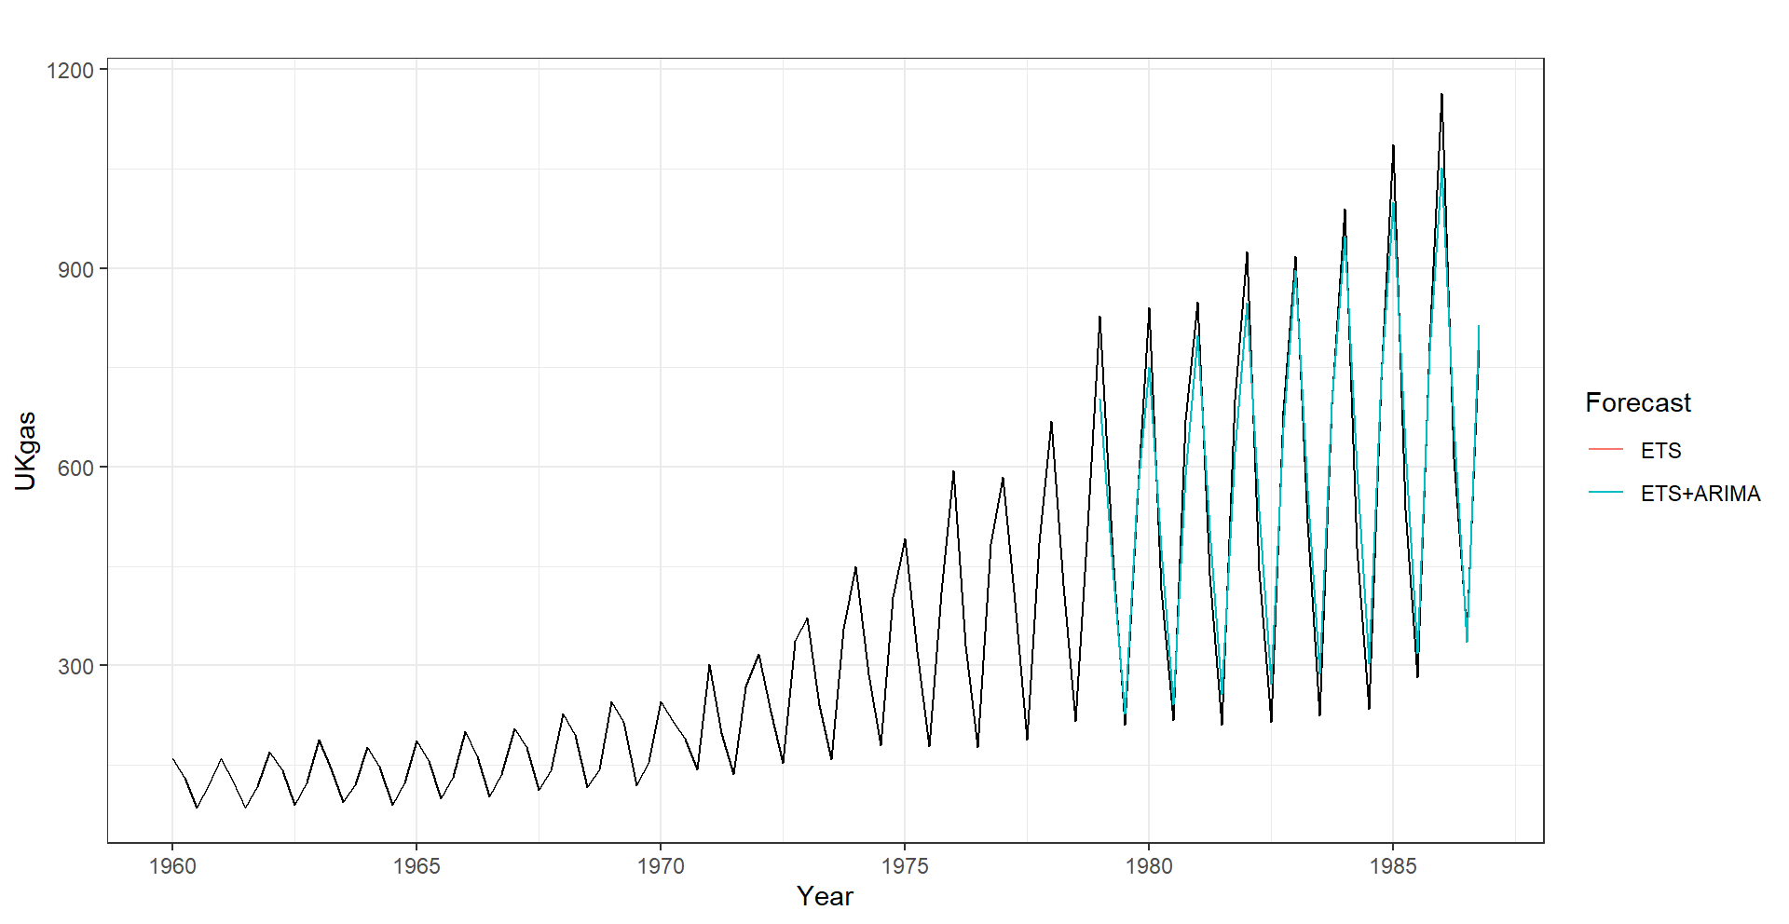  (a) | 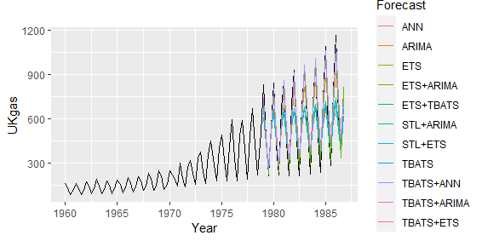  (b)
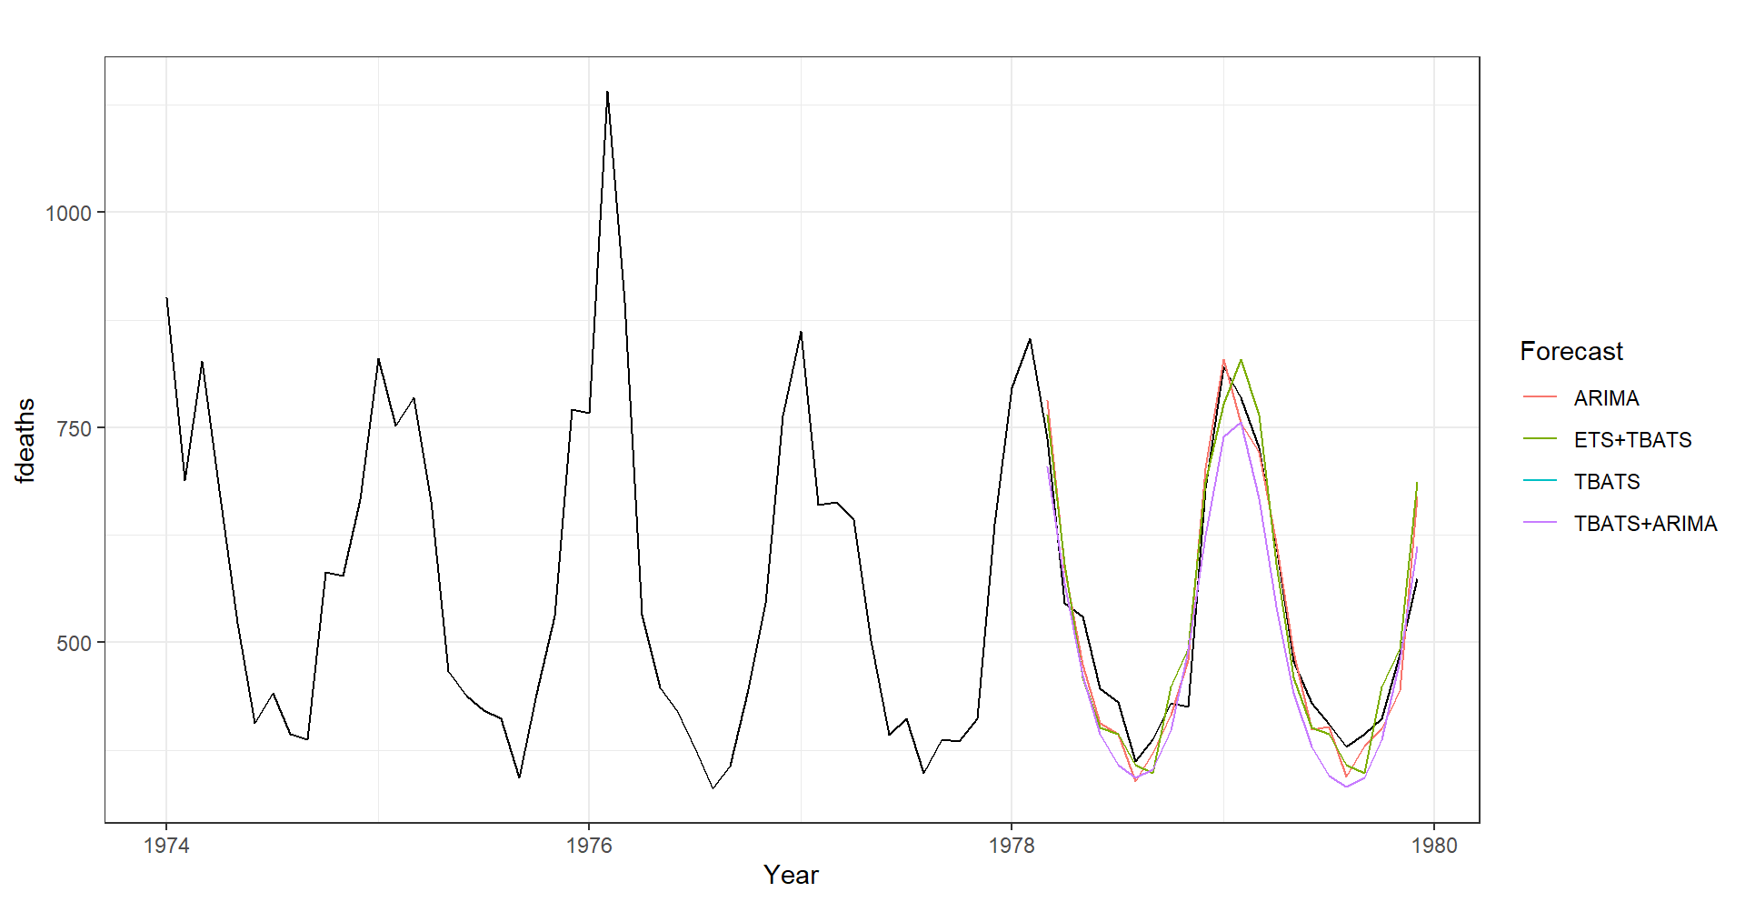  (c) | 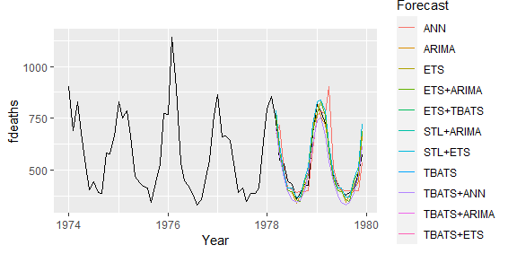  (d)

Figure 3. Forecast Plot Based on the Training Dataset for Trend with Multiplicative Seasonality (a & b); No Trend with Multiplicative Seasonality (c & d)

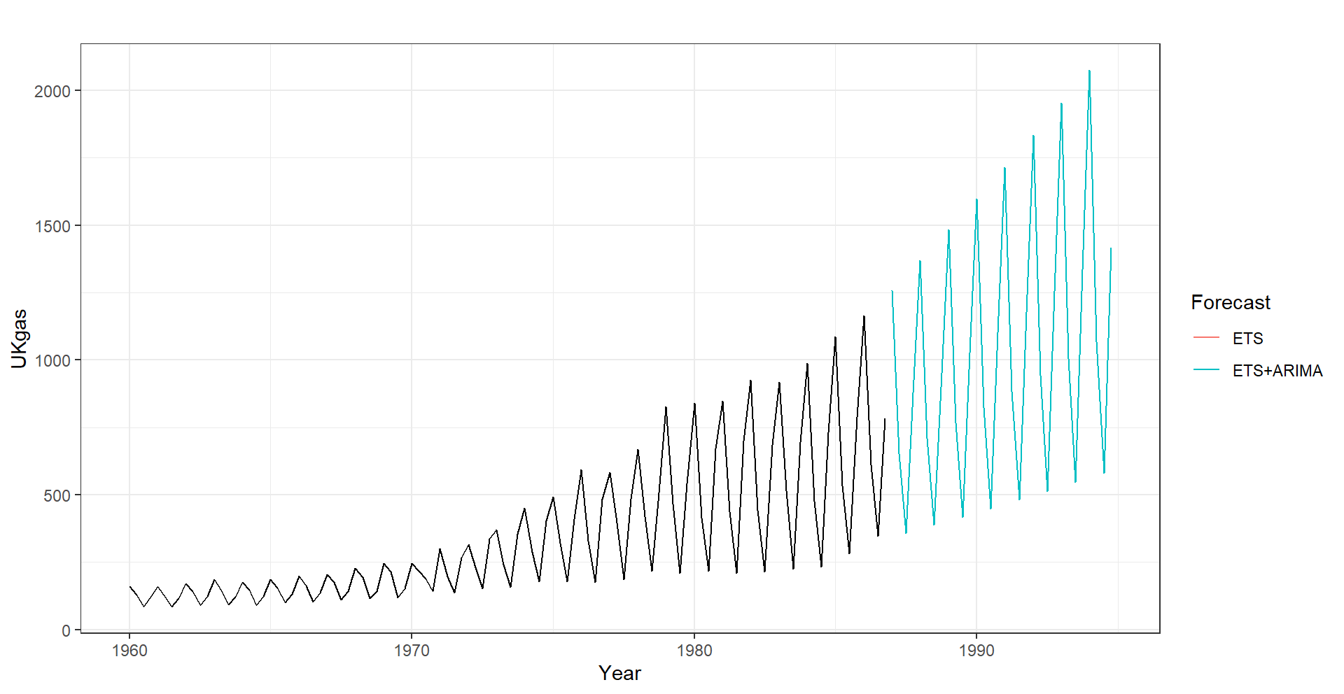  (a) | 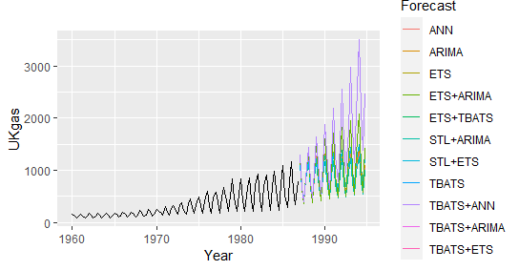  (b)
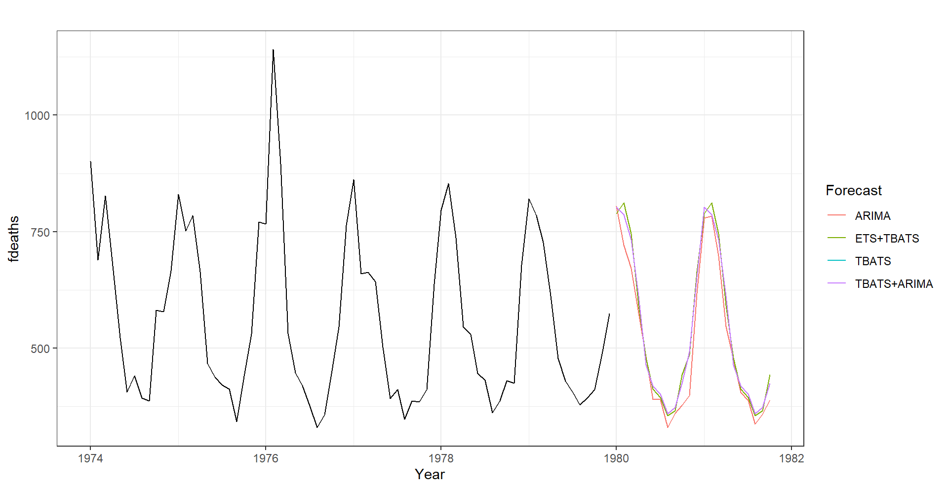  (c) | 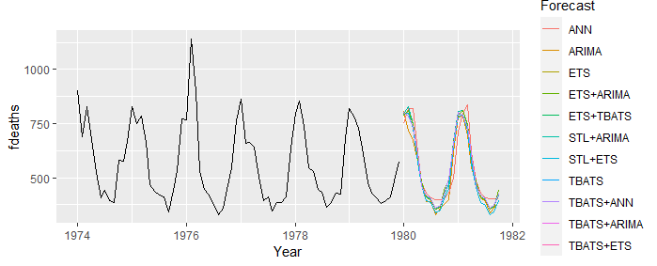  (d)

Figure 4. Forecast Plot Based on the Entire Dataset for Trend with Multiplicative Seasonality (a & b); No Trend with Multiplicative Seasonality (c & d)
The authors conducted a simulation study for trends with multiplicative seasonality scenarios. The parameter estimates (α̂ = 0.0305, β̂ = 0.0305, γ̂ = 0.6238) were obtained by fitting an ETS (M,A,M) model to the UKgas dataset. These estimates represent the smoothing parameters for level (α), trend (β), and seasonality (γ), respectively. Similarly, for the no-trend with multiplicative seasonality scenario, the parameters (α̂ = 0.074, γ̂ = 1e-04) were obtained by fitting an ETS (M,N,M) model to the fdeaths dataset.

3.2 Simulation Studies

To make a robust statistical evaluation, we have repeated the simulations for 100, 200, and 500 times separately for quarterly and monthly time series data. We conducted a simulation study for trends with multiplicative seasonality scenarios with the parameter estimates , , and , were obtained by fitting an ETS (M,A,M) model to the UKgas dataset. These estimates represent the smoothing parameters for level (), trend (), and seasonality (), respectively. Hence, we used the equation for data generation

(7)

where and are level, trend and seasonality equations, respectively, and and for level, trend, and seasonality parameters, respectively. Moreover, we assume multiplicative errors with . To generate the required time-series data, we generated normally and independently distributed with mean zero and unit variance, i.e., The mean and standard error of the 100, 200, and 500 independent simulations with data sizes 100 and 200 for quarterly time series are shown in Table 3. Time plots of ten realizations of the simulated trend with multiplicative seasonality time-series data starting at random seed 210409 for data points 100 and 200 are given in Figure 5.

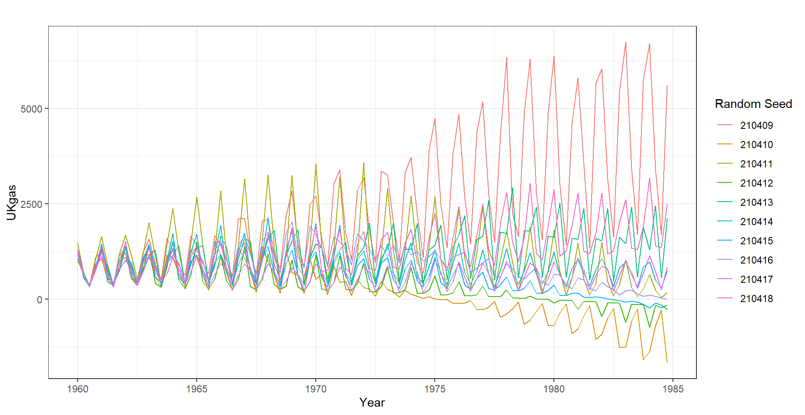 | 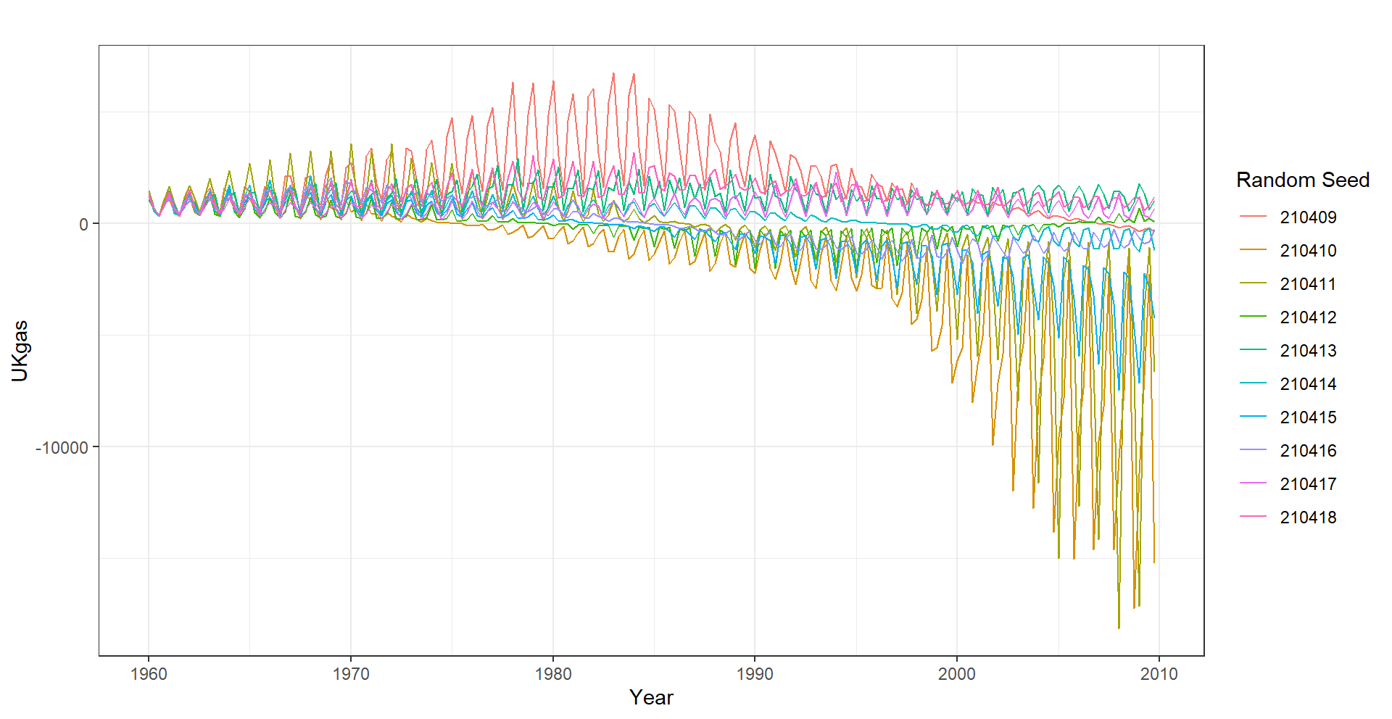
(a) | (b)

Figure 5. Time Plots of Ten Realizations of the Simulated Trend with Multiplicative Seasonality Time-Series Data Starting at Random Seed 210409 for Data Points 100 in (a) and 200 in (b)

Table 3. Estimated Forecasting Accuracy Measures of Different Models for Trend with Multiplicative Seasonality Time Series Based on Simulations $m=500$ and for Different Data Sizes $n=100, 200$.

 | Based on Simulation Size ($m=500$) and Data Size ($n=100$)
Model | MSE  Mean (SE) | RMSE  Mean (SE) | MAE  Mean (SE) | MAPE  Mean (SE)
ETS | 1383116.04  (5437735.7) | 717.80  (932.53) | 514.01  (623.67) | 89.65  (738.22)
SARIMA | 1931140.44  (10238064.48) | 825.81  (1118.78) | 603.27  (727.58) | 347.82  (4226.96)
TBATS | 3283947.31  (12447330.03) | 1009.26  (1506.61) | 737.19  (1080.19) | 182.78  (1410.76)
ANN | 4054469.28  (16885960.6) | 1158.86  (1648.32) | 855.56  (1175.43) | 327.01  (3029.26)
STL-ARIMA | 2660431.6  (13047069.61) | 977.76  (1306.84) | 720.64  (848.69) | 558.5  (8000.75)
STL-ETS | 2681907.62  (12196577.25) | 989.39  (1306.31) | 768.45  (959.55) | 370.51  (3167.14)
ETS-TBATS | 1382945.08  (5437763.21) | 717.67  (932.54) | 513.86  (623.68) | 89.71  (737.91)
ETS-ARIMA | 1382931.59  (5437767.47) | 717.60  (932.59) | 513.78  (623.73) | 89.6  (738.03)
TBATS-ETS | 3282965.05  (12447588.87) | 1008.25  (1506.96) | 736.25  (1080.45) | 181.94  (1408.58)
TBATS-ARIMA | 3282720.49  (12447619.06) | 1008.03  (1507.03) | 736.05  (1080.53) | 182.16  (1410.71)
TBATS-ANN | 3283250.86  (12447560.98) | 1008.38  (1506.97) | 736.26  (1080.5) | 182.58  (1418.68)
 | Based on Simulation Size ($m=500$) and Data Size ($n=200$)
ETS | 137480105.92  (1035083967.48) | 4618.68  (10787.99) | 3079.38  (6708.16) | 175.17  (547.64)
SARIMA | 154886937.6  (1267838329.65) | 5016.92  (11400.76) | 3449.75  (6998.43) | 231.47  (606.95)
TBATS | 283329989.42  (2299200009.8) | 6180.60  (15672.31) | 4021.94  (8591.99) | 240.76  (716.16)
ANN | 272120425.34  (2690023519.92) | 6075.24  (15351.98) | 4196.15  (10102.2) | 297.83  (871.95)
STL-ARIMA | 197442759.92  (1626884456.2) | 5550.92  (12921.45) | 3846.49  (8301.83) | 265.04  (655.81)
STL-ETS | 196293016.12  (1597948316.31) | 5484.57  (12905.26) | 3895.14  (8599.83) | 258.69  (662.29)
ETS-TBATS | 137471689.9  (1035084769.27) | 4616.79  (10788.41) | 3077.83  (6708.52) | 174.51  (545.9)
ETS-ARIMA | 137461627.26  (1035085583.06) | 4616.09  (10788.24) | 3076.5  (6708.47) | 174.94  (547.83)
TBATS-ETS | 283279824.51  (2299205634.7) | 6173.62  (15673.46) | 4016.76  (8592.91) | 240.73  (716.33)
TBATS-ARIMA | 283281654.84  (2299205585.8) | 6173.19  (15673.7) | 4015.64  (8593.32) | 240.51  (716.4)
TBATS-ANN | 283252448.42  (2299208455.59) | 6169.83  (15674.09) | 4012.78  (8594.11) | 239.59  (717.23)

Table 3 displays the results of our simulation studies, with a focus on forecasting accuracy measures for different models. In particular, when addressing a situation characterized by a trend with multiplicative seasonality, the ETS-ARIMA model exhibits superior performance compared to the alternative models. Fig 6 and Fig 7 illustrate the performance of various forecasting models across different accuracy measures. For metrics like RMSE, MAE, and MAPE, all eleven models exhibited similar mean and deviation values. However, it's worth noting that all models displayed outliers in their results, with the exception of the ETS-ARIMA model. The ETS-ARIMA model consistently demonstrated minimal variability and high accuracy, making it the top-performing model when compared to the others.

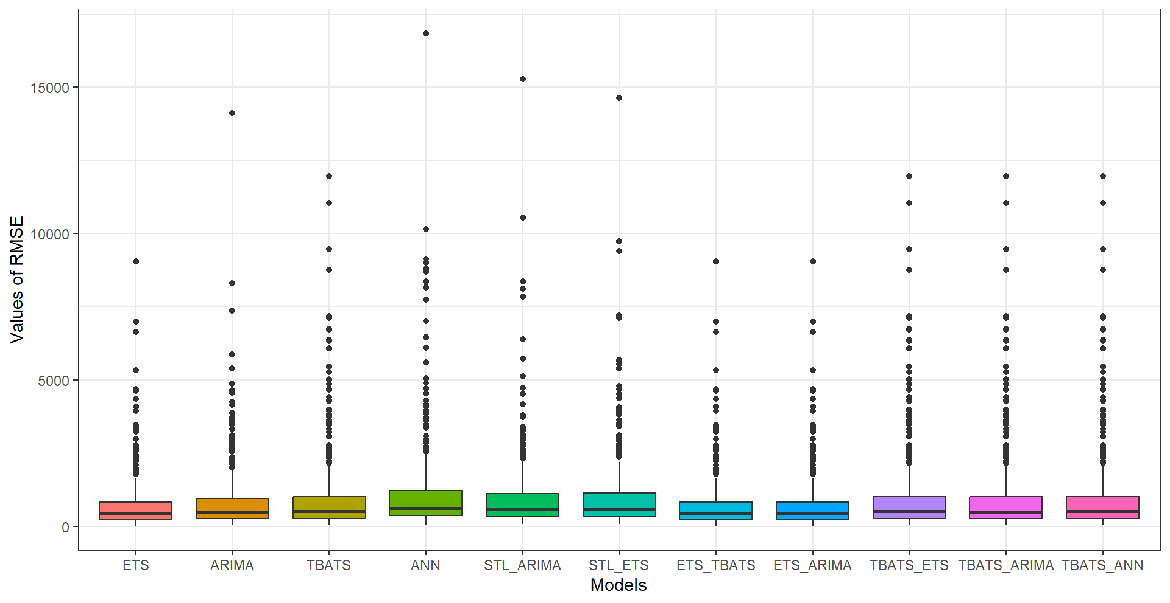  (a) | 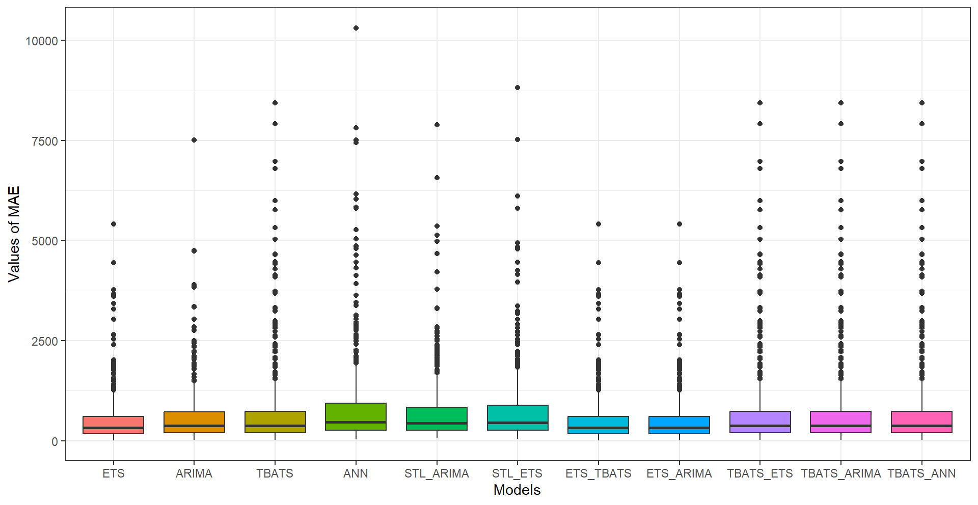  (b)
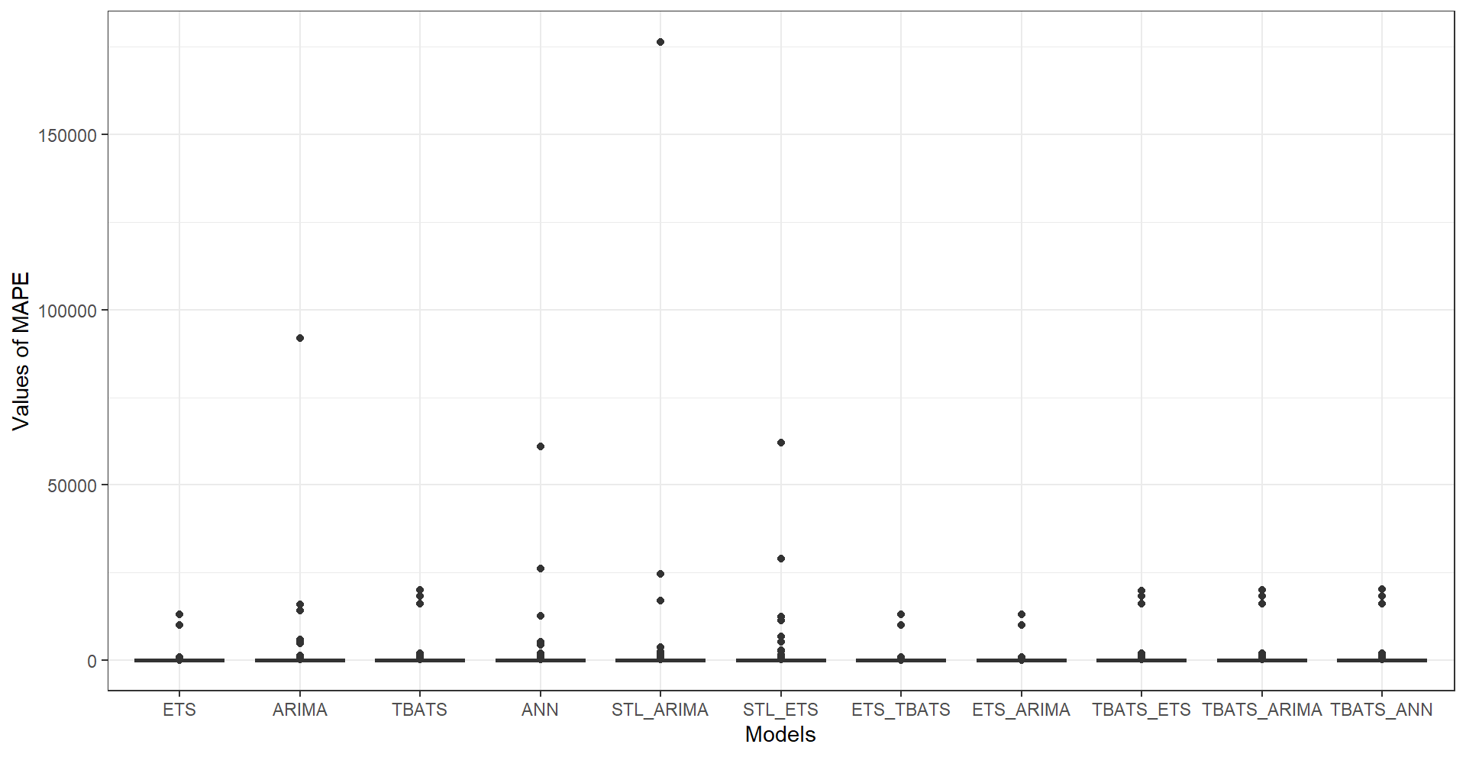
(c)
Figure 6. Boxplot Illustrates the Distribution of Each Performance Metric, i.e., (a) RMSE, (b) MAE, and (c) MAPE, Across the Different Models Based on 500 Simulations with 100 Data Points for the Trend with Multiplicative Seasonality Time Series Data

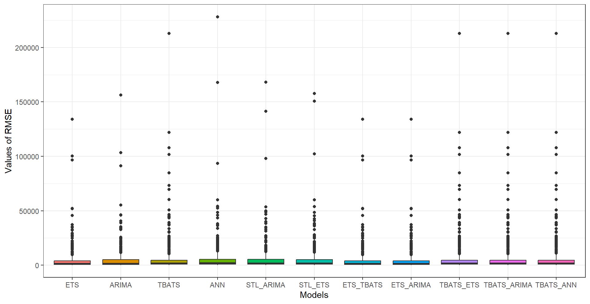  (a) | 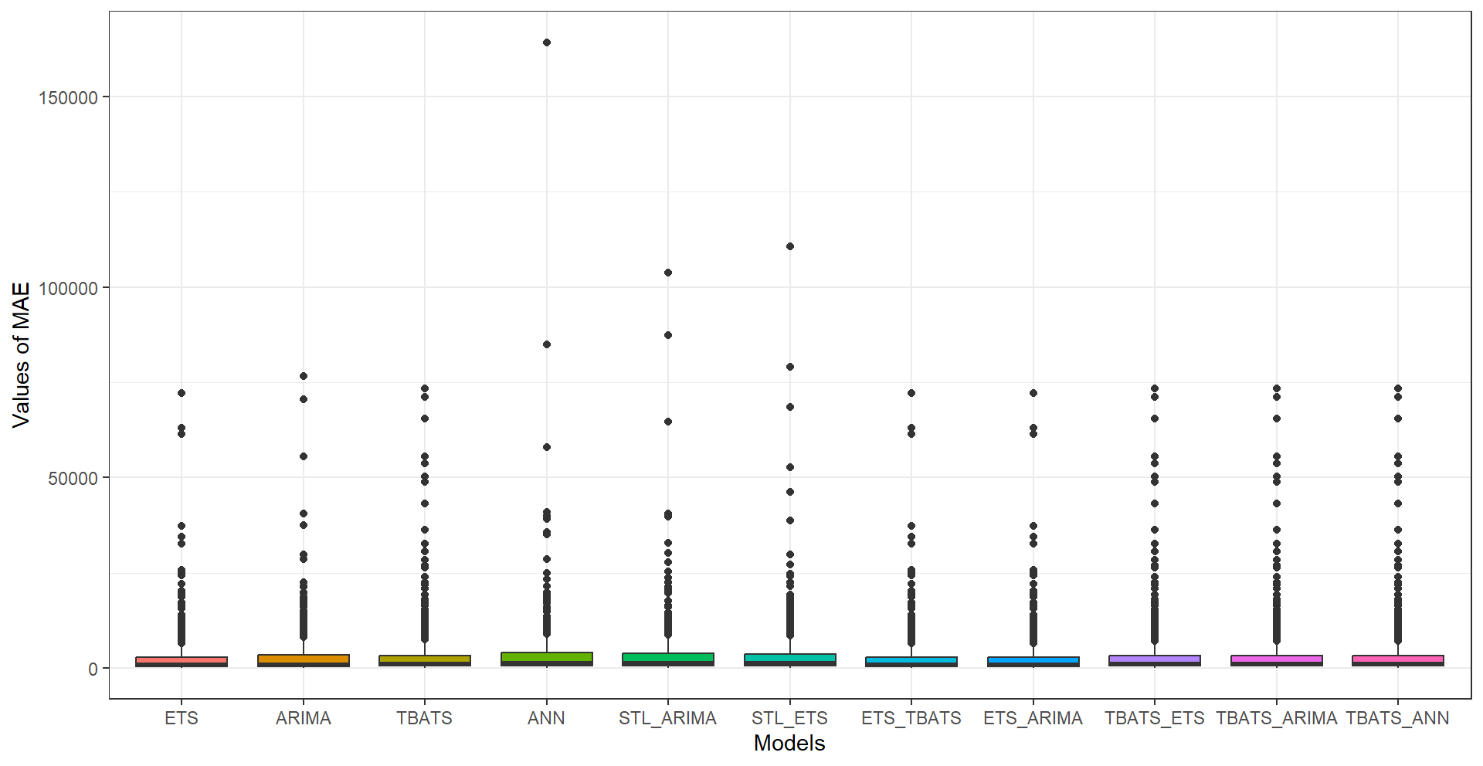  (b)
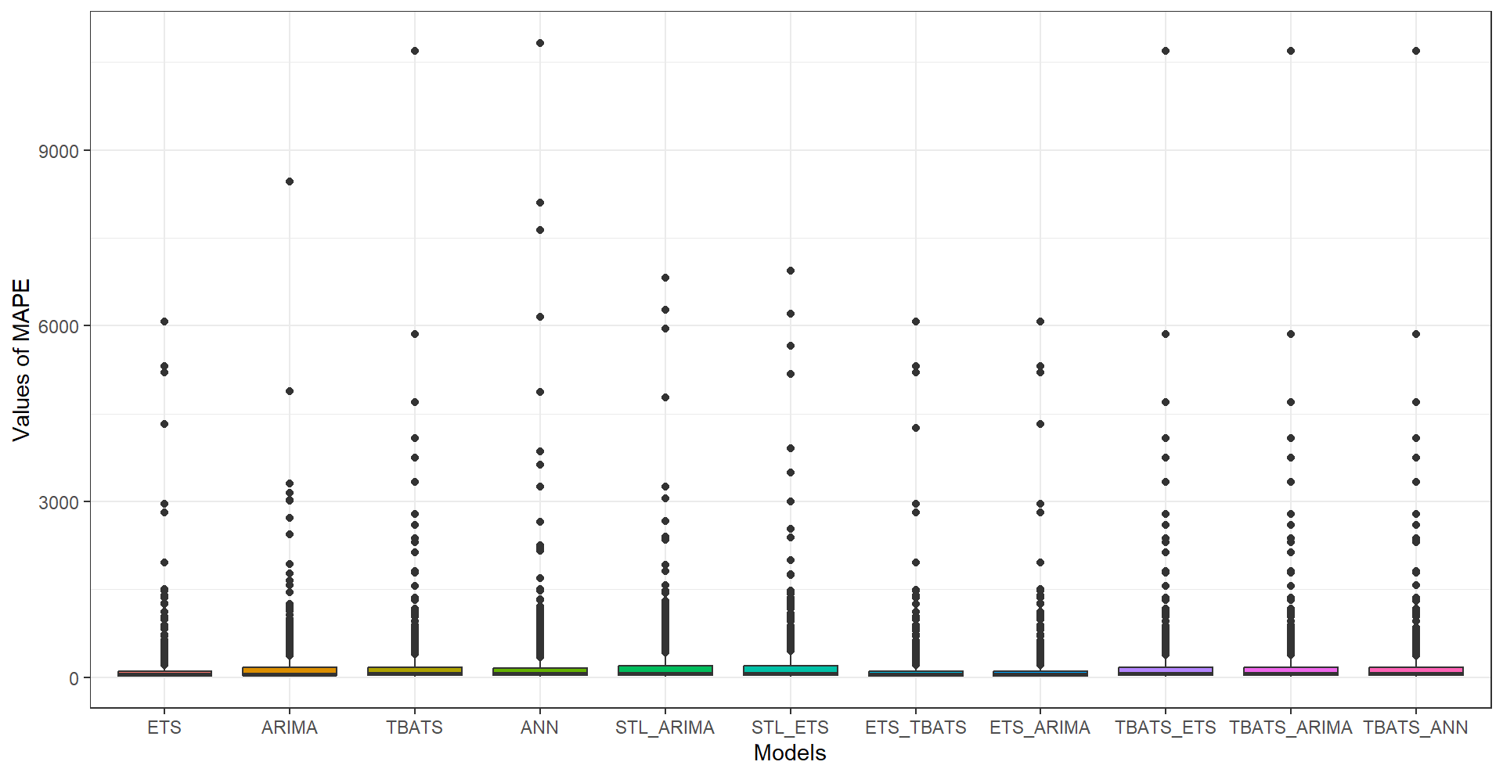
(c)

Figure 7. Boxplot Illustrates the Distribution of Each Performance Metric, i.e., (a) RMSE, (b) MAE, and (c) MAPE, Across the Different Models Based on 500 Simulations with 200 Data Points for the Trend with Multiplicative Seasonality Time Series Data

Similarly, for the no-trend with multiplicative seasonality scenario, the parameters (, and ,) were obtained by fitting an ETS(M,N,M) model to the fdeaths dataset. These estimates represent the smoothing parameters for level (), and seasonality (), respectively. Using generated normally and independently distributed with mean zero and unit variance for sample size $n$ = 100, 200, and simulation size $m$ =100, 200, 500. Hence, we use the following equations for data generation

(8)

where and are level, and seasonality equations, respectively, and and for level, trend, and seasonality parameters, respectively. Moreover, we assume multiplicative errors with . To generate the required time-series data, we generated normally and independently distributed with mean zero and unit variance, i.e., The mean and standard error of the 100, 200, and 500 independent simulations with data sizes 100 and 200 for monthly time series are shown in Table 4. Moreover, time plots of ten realizations of the simulated no trend with multiplicative seasonality time-series data starting at random seed 210409 for data points 100 and 200 are given in Figure 8.

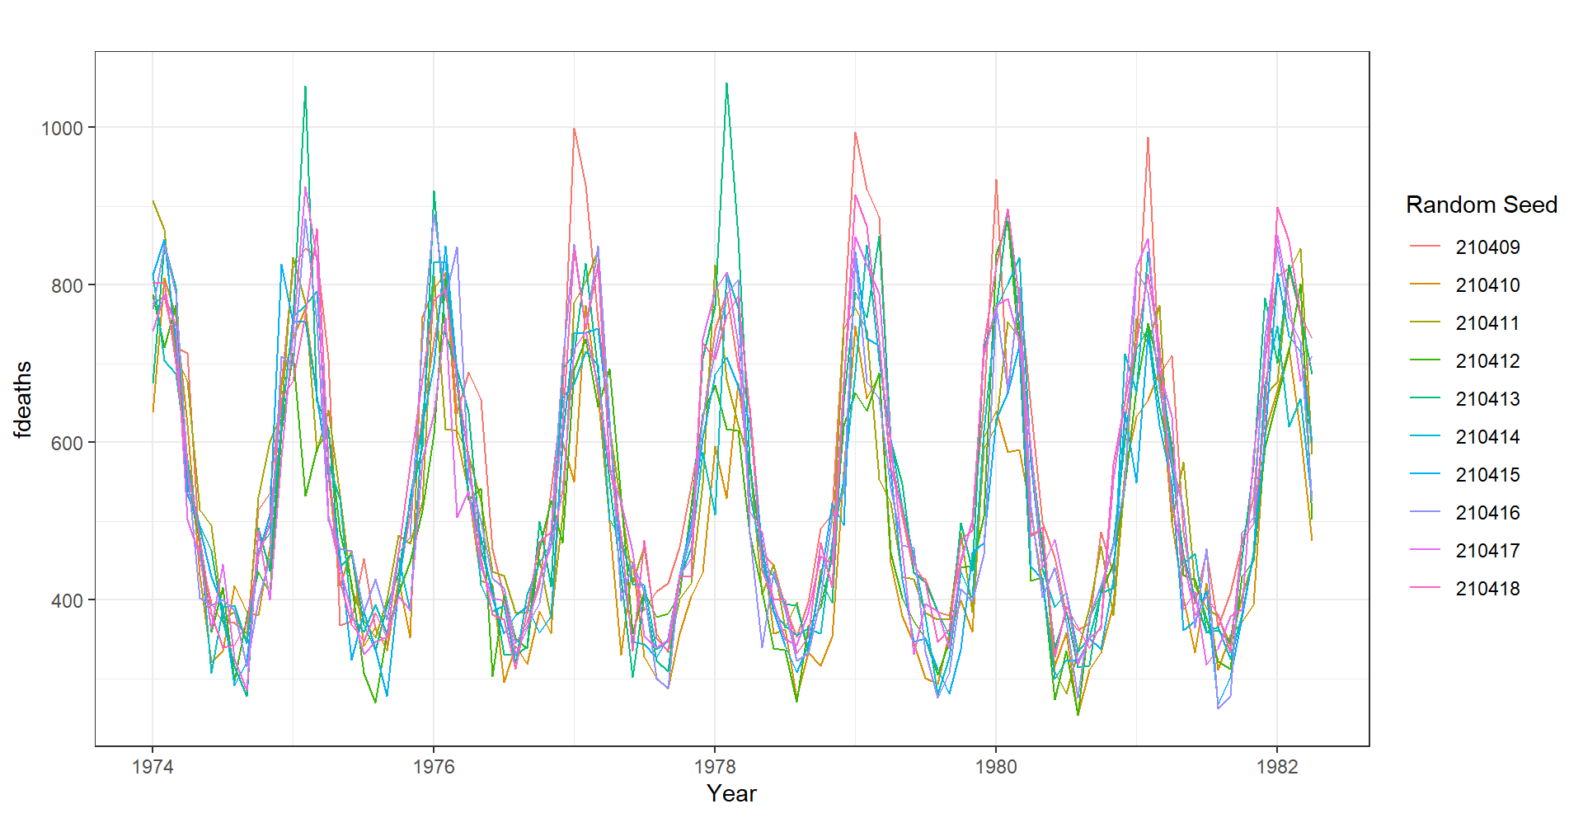 | 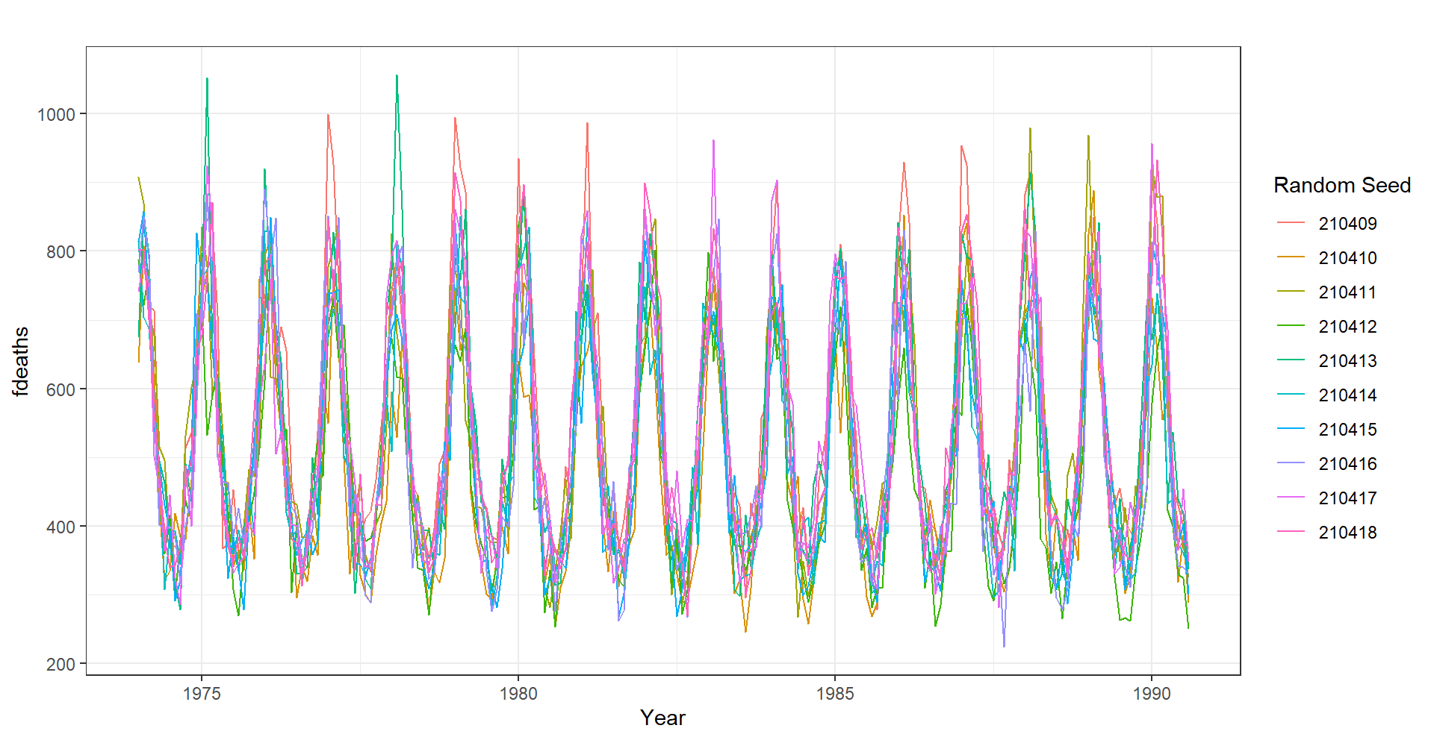
(a) | (b)

Figure 8. Time Plots of Ten Realizations of the Simulated no Trend with Multiplicative Seasonality Time-Series Data Starting at Random Seed 210409 for Data Points 100 in (a) and 200 in (b)

Table 4. Estimated Forecasting Accuracy Measures of Different Models for no Trend with Multiplicative Seasonality Time Series Based on Simulations $m=500$ and for Different Data Sizes $n=100, 200$.

 | Based on Simulation Size ($m=500$) and Data Size ($n=100$)
Model | Mean- MSE (SE) | Mean- RMSE (SE) | Mean- MAE (SE) | Mean- MAPE (SE)
ETS | 5389.36  (2658.3) | 71.93  (14.69) | 56.05  (11.49) | 10.04  (2.03)
SARIMA | 6377.85  (2463.89) | 78.43  (15.07) | 61.5  (12.03) | 11.04  (2.2)
TBATS | 5331.27  (2352.52) | 71.57  (14.48) | 56.11  (11.72) | 10.06  (2.09)
ANN | 9949.83  (7527.53) | 96.42  (25.57) | 75.02  (18.76) | 13.4  (3.17)
STL-ARIMA | 5396.23  (2028.88) | 72.24  (13.36) | 56.51  (10.48) | 10.13  (1.91)
STL-ETS | 5524.5  (2255.26) | 72.96  (14.23) | 57.27  (11.39) | 10.3  (2.11)
ETS-TBATS | 5389.3  (2656.33) | 71.93  (14.68) | 56.06  (11.48) | 10.04  (2.02)
ETS-ARIMA | 5405.85  (2660.81) | 72.04  (14.7) | 56.16  (11.51) | 10.06  (2.03)
TBATS-ETS | 5349.2  (2375.82) | 71.68  (14.53) | 56.23  (11.83) | 10.09  (2.12)
TBATS-ARIMA | 5351.34  (2349.24) | 71.71  (14.48) | 56.26  (11.69) | 10.09  (2.08)
TBATS-ANN | 5454.39  (2425.15) | 72.36  (14.79) | 56.73  (11.96) | 10.19  (2.16)
Based on Simulation Size ($m=500$) and Data Size ($n=200$)
ETS | 4980.16  (3067.9) | 68.83  (15.57) | 53.17  (13.04) | 10.01  (2.22)
SARIMA | 5700.9  (2293.02) | 74.17  (14.15) | 57.83  (11.62) | 10.95  (2.11)
TBATS | 4805.33  (1883.59) | 68.17  (12.57) | 52.59  (9.9) | 9.87  (1.66)
ANN | 8863.24  (4493.92) | 91.71  (21.3) | 70.99  (16.79) | 13.45  (3.11)
STL-ARIMA | 5007.81  (1844.21) | 69.68  (12.33) | 53.86  (9.86) | 10.15  (1.71)
STL-ETS | 5234.7  (2489.56) | 70.79  (14.95) | 54.93  (12.55) | 10.39  (2.35)
ETS-TBATS | 4978.79  (3067.43) | 68.83  (15.56) | 53.16  (13.03) | 10.01  (2.22)
ETS-ARIMA | 4979.96  (3068.11) | 68.83  (15.57) | 53.17  (13.04) | 10.01  (2.22)
TBATS-ETS | 4803.72  (1877.89) | 68.17  (12.55) | 52.59  (9.88) | 9.88  (1.67)
TBATS-ARIMA | 4801.53  (1875.71) | 68.15  (12.53) | 52.58  (9.87) | 9.87  (1.66)
TBATS-ANN | 4813.06  (1896.07) | 68.22  (12.64) | 52.66  (9.99) | 9.89  (1.7)

Table 4 displays the results of our simulations, with a focus on forecasting accuracy measures for different models. In this situation, for simulation size m=500 and n=100, TBATS (for MSE, RMSE) and ETS-TBATS (for MAE, MAPE) models exhibit the best performance and for simulation size m=500 and n=200, TBATS-ARIMA model exhibits superior performance compared to alternative models. Figure 9 and Figure 10 illustrate different forecasting accuracy measures’ performances for different models. For simulation size m=500 and n=100, TBATS (MSE, RMSE) and ETS-TBATS (MAE, MAPE) models showed consistent performance with minimum variability and high accuracy, and for simulation size m=500 and data size n=200, TBATS-ARIMA hybrid model performed better than other models.

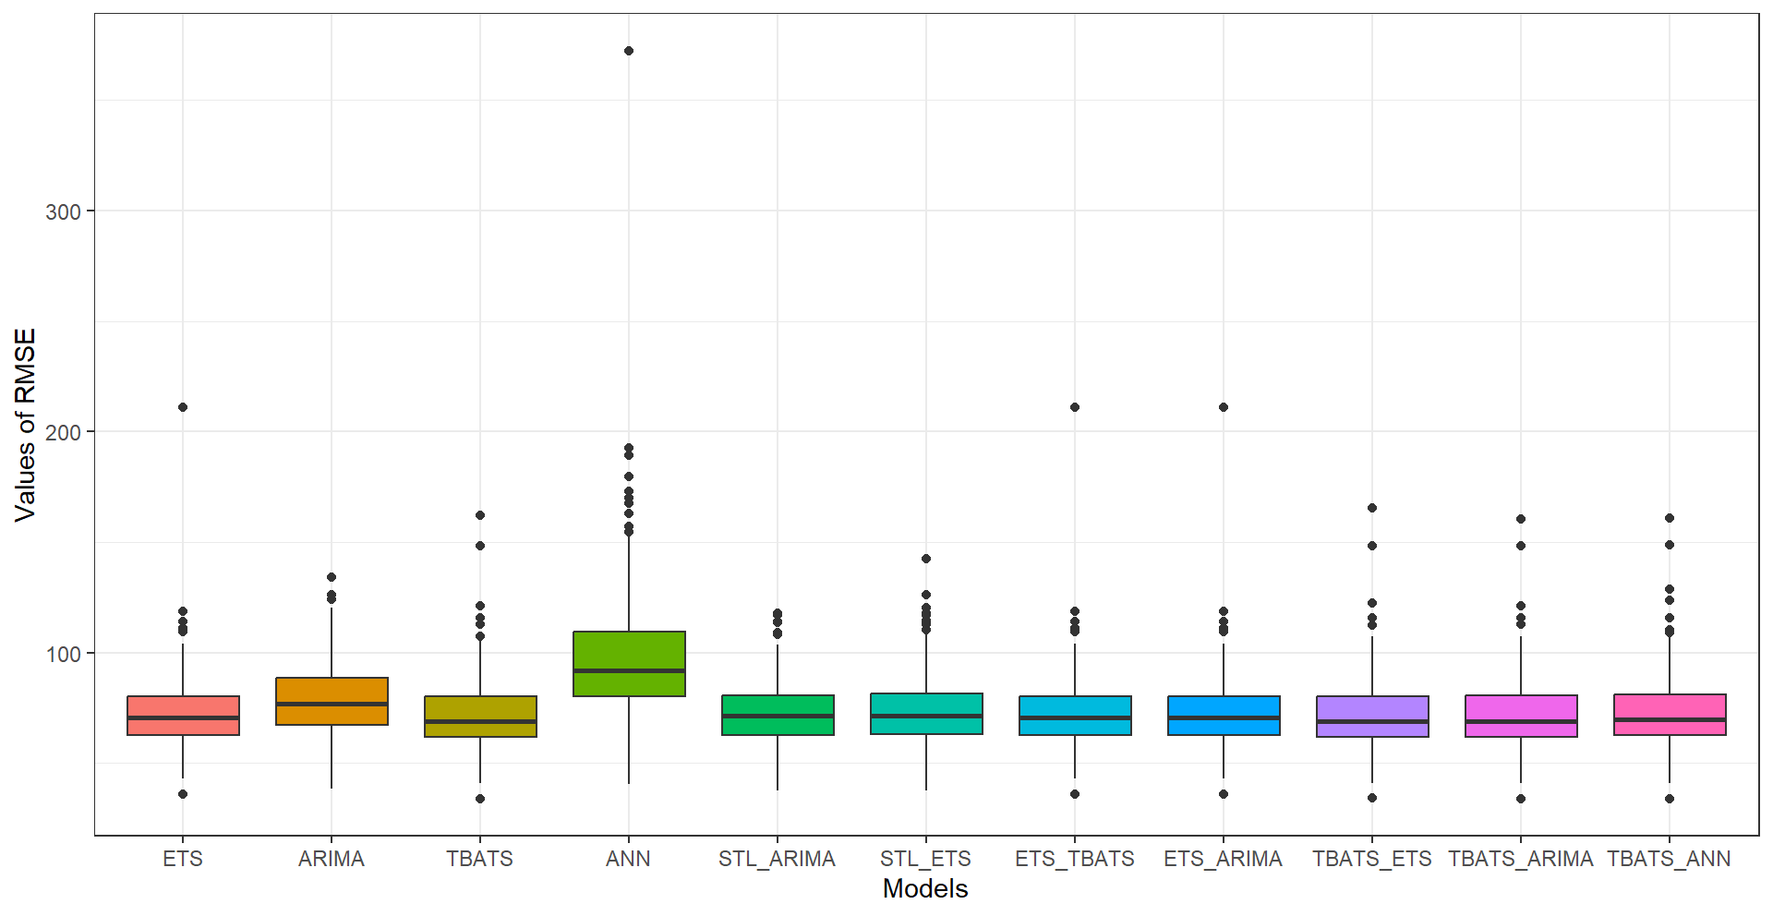  (a) | 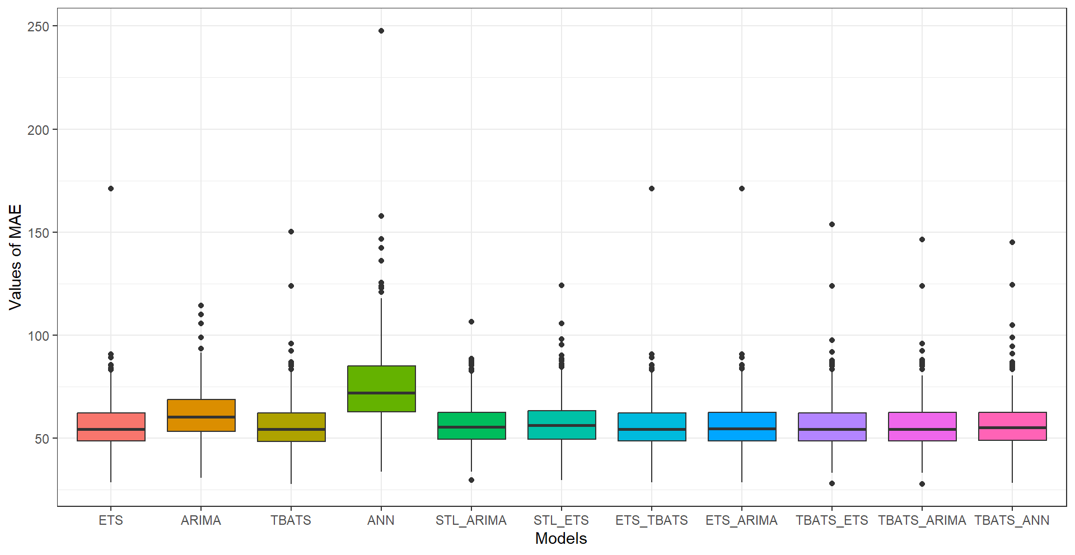  (b)
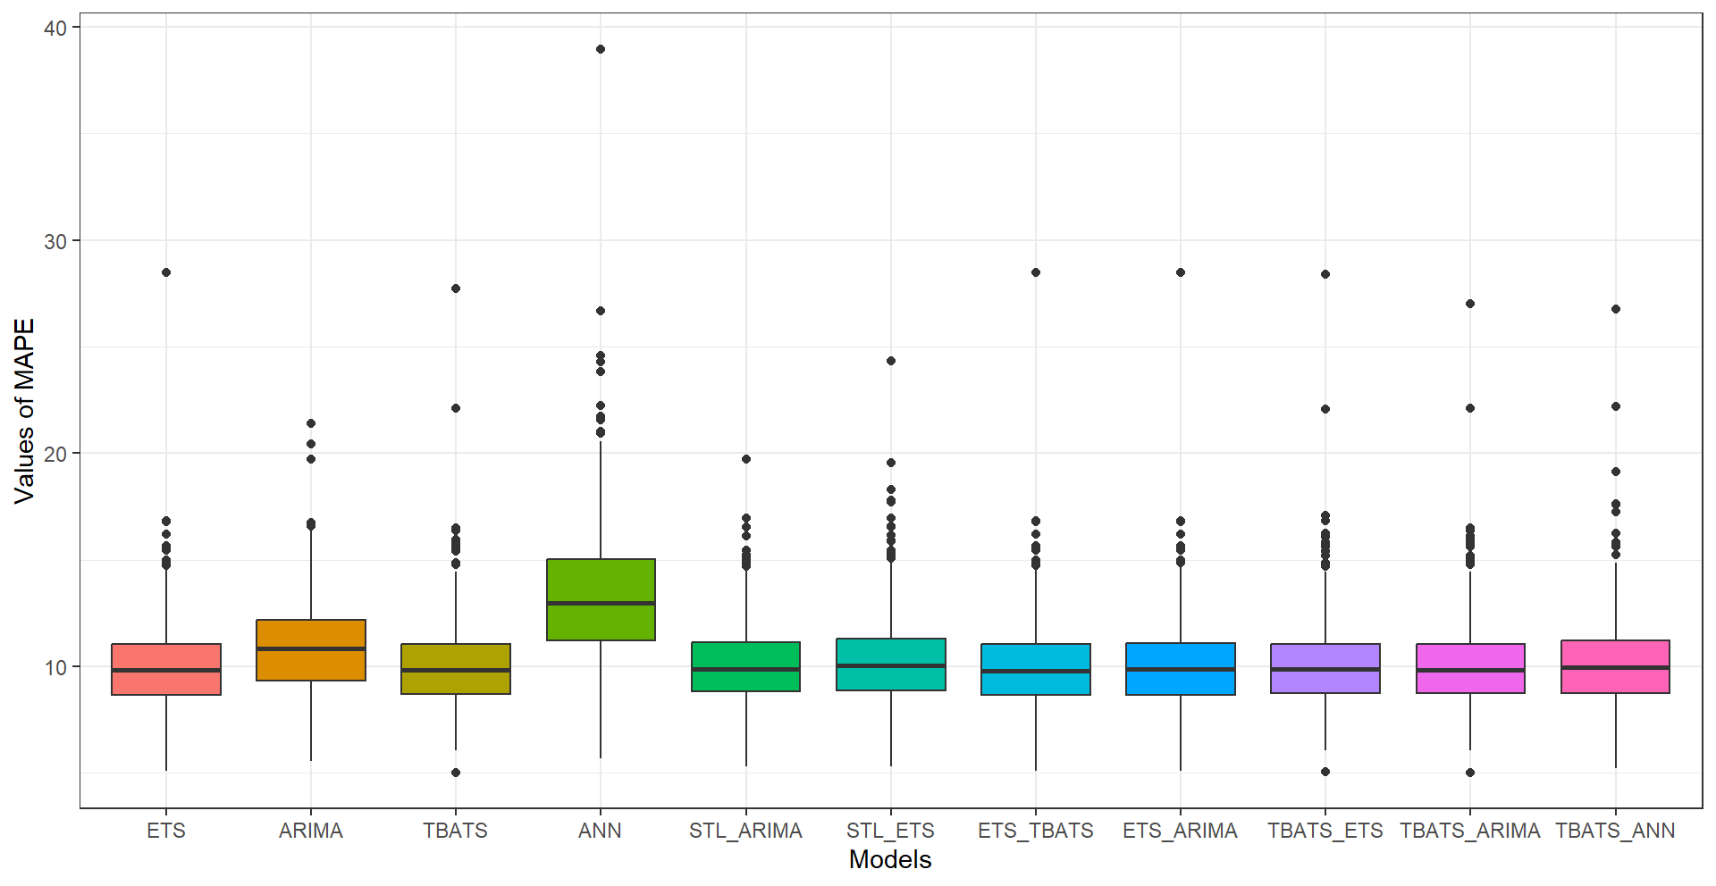
(c)

Figure 9. Boxplot Illustrates the Distribution of Each Performance Metric, i.e., (a) RMSE, (b) MAE, and (c) MAPE, Across the Different Models Based on 500 Simulations with 100 Data Points for No Trend with Multiplicative Seasonality Time Series Data

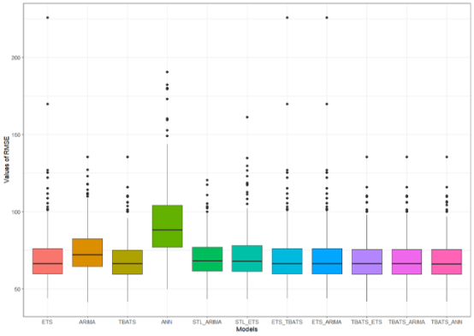  (a) | 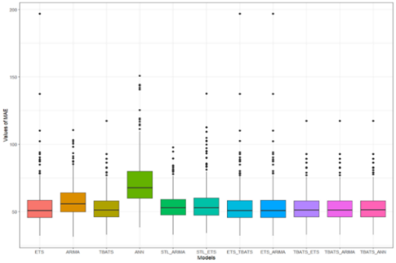  (b)
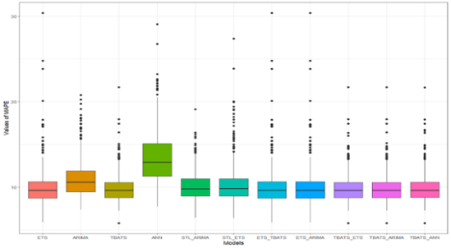
(c)
Figure 10. Boxplot Illustrates the Distribution of Each Performance Metric, i.e., (a) RMSE, (b) MAE, and (c) MAPE, Across the Different Models Based on 500 Simulations with 200 Data Points for No Trend with Multiplicative Seasonality Time Series Data
The standard errors reported in Tables 3 and 4 are notably large, in some cases exceeding the mean values. This indicates substantial variability in forecast accuracy across simulation runs. Such variability is expected when generating data with multiplicative seasonality and random innovations, as different realizations can produce diverse trajectory shapes. Consequently, while we report which models achieved the lowest average error metrics, these results should be interpreted with caution. No single model is consistently superior across all simulation runs. We have therefore emphasized tendencies in performance rather than making claims of universal superiority.

Discussion

Multiplicative seasonality is a common characteristic in time-series data where the seasonal effects vary with the level of the series (Gould et al., 2008). This can complicate forecasting efforts, necessitating the use of sophisticated models that can accurately capture these dynamics (Ngo et al., 2022). Moreover, the most widely used ARIMA model is unable to enhance prediction performance in this circumstance. Therefore, recent studies (Band et al., 2022; Ngo et al., 2022; Schmid et al., 2025); have explored various machine learning (ML), time-series, and hybrid models to enhance predictive performance in this context. For example, in retail sales forecasting, the seasonal effects may vary based on factors like marketing promotions, holidays, weather patterns, or economic conditions. Traditional ARIMA models may struggle to accurately predict sales fluctuations during these variable seasonal periods (Teixeira et al., 2024). However, in certain industries, the seasonal effects are consistent regardless of the level of the series, such as in agricultural commodities where planting and harvesting seasons remain relatively constant. In such cases, simpler forecasting methods like ARIMA may still be effective and more suitable than complex ML and hybrid models (Jadhav et al., 2017; Mahto et al., 2021; Paul et al., 2022). Hence, the aim of this study was to assess the forecasting performance of various ML, time-series, and hybrid models for multiplicative seasonality with various trends in time-series data. Our analysis included eleven models: ETS, SARIMA, TBATS, ANN, STL-ARIMA, STL-ETS, ETS-ARIMA, ETS-TBATS, TBATS-ETS, TBATS-ARIMA, and TBATS-ANN. The findings from our real data and simulation studies reveal nuanced insights into model performance across different scenarios.

In real data analysis, our findings revealed that the ETS model (MSE= 4026.862, RMSE= 63.4575, MAE= 54.5273, MAPE= 11.5188) demonstrated superior forecasting accuracy compared to other models for the trend with multiplicative seasonality situation. This result is consistent with prior findings that emphasize the effectiveness of ETS in handling seasonal patterns (Hyndman & Athanasopoulos, 2018; Makridakis, 2000). ETS models are known for their ability to adapt to various seasonality levels and structural changes within the data, contributing to their success in the multiplicative dataset. Conversely, the SARIMA model (MSE= 1305.594, RMSE= 36.133, MAE= 28.9562, MAPE= 5.8360) performed best with the no trend with multiplicative seasonality dataset in real data analysis. This aligns with traditional views on SARIMA’s ability to model linear trends and autocorrelations effectively (Hays, 2021; MW & Enders, 1995). The relatively stable underlying patterns in the data, with less pronounced multiplicative seasonality, might explain SARIMA's superior performance.

Our simulation studies provided additional insights into model performance under varying conditions. For the trend with multiplicative seasonality data, both the ETS-ARIMA hybrid model (MSE= 1382931.59, RMSE= 717.60, MAE= 513.78, MAPE= 89.6) exhibited strong performance in simulations with a simulation size 500 and data sizes 100 and ETS-ARIMA (MSE= 137461627.26, RMSE= 4616.09, MAE= 3076.5, MAPE= 174.94) for simulation size 500 and data size 200. The combination of ETS and SARIMA leverages the strengths of both models, capturing multiplicative seasonality and autocorrelation simultaneously. This hybrid approach is supported by (G. P. Zhang & Qi, 2005), who showed that combining different models can improve forecasting accuracy by addressing multiple aspects of the data. In the no trend with multiplicative seasonality data simulations, TBATS (MSE= 5331.27, RMSE= 71.57) performed exceptionally well in terms of MSE and RMSE for a simulation size of 500 and data size of 100. TBATS’s capacity to manage complex seasonal and trend structures made it particularly suitable for the multiplicative data (Livera et al., 2010b). For the same dataset, the ETS-TBATS (MAE= 56.06, MAPE= 10.04) hybrid model achieved the best results in terms of MAE and MAPE, further indicating that hybrid models can offer enhanced performance by integrating the strengths of different methodologies. For simulation size 500 and data size 200, the TBATS-ARIMA (MSE= 4801.53, RMSE= 68.15, MAE= 52.58, MAPE= 9.87) model performed best, reflecting its ability to adapt to larger datasets and more complex seasonality. This is consistent with findings in forecasting competitions where complex and hybrid models often outperform simpler ones when handling intricate time series patterns (Makridakis et al., 2018; Singh & Huang, 2019).

A notable concern in the simulation results is the large standard errors reported in Tables 3 and 4, in some cases exceeding the mean values. This indicates substantial variability in forecast accuracy across simulation runs. Such variability is expected when generating data with multiplicative seasonality and random innovations, as different realizations can produce diverse trajectory shapes. Consequently, while we report which models achieved the lowest average error metrics, these results should be interpreted with caution. No single model is consistently superior across all simulation runs. We have therefore emphasized tendencies in performance rather than making claims of universal superiority. Future studies may consider reporting medians or using bootstrap confidence intervals to better characterize this uncertainty. Our simulation study was limited to parameter estimates derived from two specific datasets (UKgas and fdeaths). While this grounds the simulations in realistic values, it does not support broad claims of model superiority across all multiplicative seasonality contexts. Future work should explore a wider range of parameter configurations (e.g., via factorial design) and additional seasonal patterns (e.g., longer periods, multiple seasonalities). Additionally, due to the exploratory nature of this study and the high variability observed in simulation results, we did not perform formal pairwise statistical tests (e.g., Diebold-Mariano) to compare models. In simulation studies with many models and high forecast error variance, such tests are prone to Type I error and often violate underlying assumptions (e.g., stationarity of loss differentials). Our conclusions are therefore based on descriptive comparisons of average accuracy metrics with standard errors, which we believe is a more transparent approach given the data characteristics.

Our findings align with the broader literature that suggests no single model universally outperforms others across all datasets. Rather, the particular features of the data have a significant impact on the model's performance. The superior performance of hybrid models in this study echoes the results found in other research, which highlights the benefits of combining models to capture different data features effectively (Bollerslev & Ghysels, 1996; Zhang, 2003). Furthermore, the success of hybrid models in complex scenarios supports the conclusions of recent studies (Hyndman & Athanasopoulos, 2018; G. P. Zhang & Qi, 2005), which emphasizes the flexibility and improved performance of hybrid approaches over traditional models alone. Hence, hybrid models have emerged as a promising approach for enhancing predictive accuracy, particularly in contexts involving multiplicative seasonality (Y. Zhang et al., 2023; Zhou et al., 2023). The hybrid models combine various predictive techniques to leverage their strengths and mitigate their weaknesses. Their ability to combine diverse modeling techniques not only improves accuracy but also enhances interpretability, making them essential for informed decision-making in various fields such as finance, retail industry, and transportation, where multiplicative seasonality may arise based on factors such as promotions, holidays, weather, or economic conditions.

Conclusion

Overall, this study contributes to the understanding of forecasting performance in the presence of multiplicative seasonality by comparing traditional time series, machine learning, and hybrid models across different scenarios. Our results suggest that while traditional models like ETS and ARIMA are effective under certain conditions, hybrid models can offer improved performance in certain scenarios, particularly when the base model leaves meaningful residual structure. However, the choice of model should be guided by the specific characteristics of the data, and no single model is universally superior.

Declarations

Availability of data and materials: The datasets that support the findings of this study are available on request.

Funding Information: There is no funding for this work.

Authors’ Contributions: JFN contributed to processing, and analyzing data, and interpreting the results, editing, and drafting the manuscript. KAR and FAB contributed to analyzing data and editing the manuscript. MR critically examined and revised the manuscript. MMH gave invaluable input in the preparation of the manuscript, and critically reviewed and edited the manuscript. RR conceptualized the research idea, and design, and supervised the study. The final version has been approved by all authors.

Conflicts of interest: No conflict of interest exists among the authors.

Acknowledgment: The authors would like to thank the anonymous reviewers and the editor for insightful feedback that largely contributed to improving the text’s quality.

References

Bajaj, A. (2023). ARIMA & SARIMA: Real-World Time Series Forecasting. Neptune Labs. https://neptune.ai/blog/arima-sarima-real-world-time-series-forecasting-guide
Band, S. S., Karami, H., Jeong, Y.-W., Moslemzadeh, M., Farzin, S., Chau, K.-W., Bateni, S. M., & Mosavi, A. (2022). Evaluation of Time Series Models in Simulating Different Monthly Scales of Drought Index for Improving Their Forecast Accuracy. Frontiers in Earth Science, 10, 10:839527.
Bollerslev, T., & Ghysels, E. (1996). Periodic Autoregressive Conditional Heteroscedasticity. Journal of Business & Economic Statistics, 14(2), 139–151.
Brożyna, J., Mentel, G., Szetela, B., & Strielkowski, W. (2018). Multi-seasonality in the tbats model using demand for electric energy as a case study. Economic Computation and Economic Cybernetics Studies and Research, 52(1), 229–246. https://doi.org/10.24818/18423264/52.1.18.14
Erő, J., & Szűcs, J. (1974). Statistical Model. In Nuclear Structure Study with Neutrons (pp. 477–482). https://doi.org/10.1007/978-1-4613-4499-5_24
Gardner, E. S. (1985). Exponential smoothing: The state of the art. J. Forecast., 4, 1–28. https://doi.org/10.1002/for.3980040103
Gould, P. G., Koehler, A. B., Ord, J. K., Snyder, R. D., Hyndman, R. J., & Vahid-Araghi, F. (2008). Forecasting time series with multiple seasonal patterns. European Journal of Operational Research, 191(1), 207–222. https://doi.org/https://doi.org/10.1016/j.ejor.2007.08.024
Hasan, M. K., Ahmed, A. B., Islam, K. Z., & Rois, R. (2025). Enhancing Forecast Accuracy for Damped Trend and Multiplicative Seasonality: A Hybrid Time-Series Framework with Simulation Study. Jahangirnagar University Journal of Science, 45(1).
Hays, J. C. (2021). Time Series Analysis Models with Trends. 19.
Hewamalage, H., Bergmeir, C., & Bandara, K. (2020). Recurrent Neural Networks for Time Series Forecasting: Current Status and Future Directions.
Hyndman, R. J., & Athanasopoulos, G. (2018). Forecasting: Principles and Practice (2nd ed.). OTexts: Melbourne, Australia.
Hyndman, R. J., & Athanasopoulos, G. (2021). Forecasting: Principles and Practice (3rd Editio). OTexts: Melbourne, Australia.
Jadhav, V., Chinnappa Reddy, B. V., & Gaddi, G. M. (2017). Application of ARIMA model for forecasting agricultural prices. Journal of Agricultural Science and Technology, 19(5), 981–992.
Kang, Y. (2020). GRATIS : G ene RA ting TI me S eries with diverse and controllable characteristics.
Khandelwal, I., Adhikari, R., & Verma, G. (2015). Time series forecasting using hybrid arima and ann models based on DWT Decomposition. Procedia Computer Science, 48(C), 173–179. https://doi.org/10.1016/j.procs.2015.04.167
Khashei, M., & Bijari, M. (2011). A new hybrid methodology for nonlinear time series forecasting. Modelling and Simulation in Engineering, 2011. https://doi.org/10.1155/2011/379121
Kim, K. G. (2016). Deep Learning. Healthcare Informatics Research, 22(4), 351–354.
Livera, A. M. De, Hyndman, R. J., & Snyder, R. D. (2010a). Forecasting time series with complex seasonal patterns using exponential smoothing Forecasting time series with complex seasonal patterns using exponential smoothing. October.
Livera, A. M. De, Hyndman, R. J., & Snyder, R. D. (2010b). Forecasting time series with complex seasonal patterns using exponential smoothing Forecasting time series with complex seasonal patterns using exponential smoothing. October.
Mahto, A. K., Alam, M. A., Biswas, R., Ahmed, J., & Alam, S. I. (2021). Short-Term Forecasting of Agriculture Commodities in Context of Indian Market for Sustainable Agriculture by Using the Artificial Neural Network. Journal of Food Quality, 2021(1), 9939906. https://doi.org/https://doi.org/10.1155/2021/9939906
Makridakis, S. (2000). The M3-Competition : results , conclusions and implications. 16, 451–476.
Makridakis, S., Spiliotis, E., & Assimakopoulos, V. (2018). Statistical and Machine Learning forecasting methods : Concerns and ways forward. PLOS ONE, 13(3), 1–26. https://doi.org/10.1371/journal.pone.0194889
Makridakis, S., Spiliotis, E., & Assimakopoulos, V. (2020). The M4 Competition: 100,000 time series and 61 forecasting methods. International Journal of Forecasting, 36(1), 54–74. https://doi.org/10.1016/j.ijforecast.2019.04.014
Makridakis, S., Wheelwright, S. C., & Hyndman, R. J. (1998). (1998). Forecasting : Methods and Applications. January 2015. https://doi.org/10.2307/2287014
MW, & Enders, W. (1995). Applied Econometric Time Series. Journal of the American Statistical Association, 90(431), 1135. https://doi.org/10.2307/2291367
Ngo, N.-T., Pham, A.-D., Truong, T. T. H., Truong, N.-S., & Huynh, N.-T. (2022). Developing a hybrid time-series artificial intelligence model to forecast energy use in buildings. Scientific Reports, 12(1), 15775. https://doi.org/10.1038/s41598-022-19935-6
Panigrahi, S., Pattanayak, R. M., Sethy, P. K., & Behera, S. K. (2021). Forecasting of Sunspot Time Series Using a Hybridization of ARIMA, ETS and SVM Methods. Solar Physics, 296(1), 1–19. https://doi.org/10.1007/s11207-020-01757-2
Paul, R. K., Yeasin, Md., Kumar, P., Kumar, P., Balasubramanian, M., Roy, H. S., Paul, A. K., & Gupta, A. (2022). Machine learning techniques for forecasting agricultural prices: A case of brinjal in Odisha, India. PLOS ONE, 17(7), e0270553.
Qureshi, M. M. U., Ahmed, A. B., Dulmini, A., Khan, M. M. H., & Rois, R. (2025). Developing a seasonal-adjusted machine-learning-based hybrid time‑series model to forecast heatwave warning. Scientific Reports, 15(1), 8699.
Rehal, V. (2022). Seasonality and Seasonal-ARIMA models. SPUR ECONOMICS. SPUR ECONOMICS - Learn and Excel. https://spureconomics.com/seasonality-and-seasonal-arima-models/
Schmid, L., Roidl, M., Kirchheim, A., & Pauly, M. (2025). Comparing Statistical and Machine Learning Methods for Time Series Forecasting in Data-Driven Logistics—A Simulation Study. In Entropy (Vol. 27, Issue 1, p. 25). https://doi.org/10.3390/e27010025
Shumway, R. H., & Stoffer, D. S. (2017a). Time Series Analysis and Applications.
Shumway, R. H., & Stoffer, D. S. (2017b). Time Series Analysis and Applications.
Singh, P., & Huang, Y. P. (2019). A new hybrid time series forecasting model based on the neutrosophic set and quantum optimization algorithm. Computers in Industry, 111, 121–139. https://doi.org/10.1016/j.compind.2019.06.004
Smith-miles, K., & Wang, X. (2006). Characteristic-Based Clustering for Time Series Data Characteristic-Based Clustering for Time Series. May 2014. https://doi.org/10.1007/s10618-005-0039-x
Suhartono. (2011). Time Series Forecasting by using Seasonal Autoregressive Integrated Moving Average: Subset, Multiplicative or Additive Model. Journal of Mathematics and Statistics, 7(1), 20–27. https://doi.org/10.3844/jmssp.2011.20.27
Taylor, S. J., Park, M., States, U., Letham, B., Park, M., & States, U. (2018). Forecasting at Scale. 1–25.
Teixeira, M., Oliveira, J. M., & Ramos, P. (2024). Enhancing Hierarchical Sales Forecasting with Promotional Data: A Comparative Study Using ARIMA and Deep Neural Networks. In Machine Learning and Knowledge Extraction (Vol. 6, Issue 4, pp. 2659–2687). https://doi.org/10.3390/make6040128
Yang, S., Deng, Z., Li, X., Zheng, C., Xi, L., Zhuang, J., Zhang, Z., & Zhang, Z. (2021a). A novel hybrid model based on STL decomposition and one-dimensionaYang, S., Deng, Z., Li, X., Zheng, C., Xi, L., Zhuang, J., Zhang, Z., & Zhang, Z. (2021). A novel hybrid model based on STL decomposition and one-dimensional convolutional neural networks w. Renewable Energy, 173, 531–543. https://doi.org/10.1016/j.renene.2021.04.010
Yang, S., Deng, Z., Li, X., Zheng, C., Xi, L., Zhuang, J., Zhang, Z., & Zhang, Z. (2021b). A novel hybrid model based on STL decomposition and one-dimensionaYang, S., Deng, Z., Li, X., Zheng, C., Xi, L., Zhuang, J., Zhang, Z., & Zhang, Z. (2021). A novel hybrid model based on STL decomposition and one-dimensional convolutional neural networks w. Renewable Energy, 173, 531–543. https://doi.org/10.1016/j.renene.2021.04.010
Zhang, G., Eddy Patuwo, B., & Y. Hu, M. (1998). Forecasting with artificial neural networks: The state of the art. International Journal of Forecasting, 14(1), 35–62. https://doi.org/10.1016/S0169-2070(97)00044-7
Zhang, G. P., & Qi, M. (2005). Neural network forecasting for seasonal and trend time series. European Journal of Operational Research, 160(2), 501–514. https://doi.org/10.1016/j.ejor.2003.08.037
Zhang, P. G. (2003). Time series forecasting using a hybrid ARIMA and neural network model. Neurocomputing, 50, 159–175. https://doi.org/10.1016/S0925-2312(01)00702-0
Zhang, Y., Tang, S., & Yu, G. (2023). An interpretable hybrid predictive model of COVID-19 cases using autoregressive model and LSTM. Scientific Reports, 13(1), 6708. https://doi.org/10.1038/s41598-023-33685-z
Zhou, F., Fan, H., Liu, Y., Zhang, H., & Ji, R. (2023). Hybrid Model of Machine Learning Method and Empirical Method for Rate of Penetration Prediction Based on Data Similarity. In Applied Sciences (Vol. 13, Issue 10, p. 5870). https://doi.org/10.3390/app13105870

Corresponding author: jannatnisha337@gmail.com © Department of Statistics and Data Science, Jahangirnagar University, Savar, Dhaka-1342, Bangladesh

